Stottesdon and Sidbury Parish Council

Clerk: Mrs Freda Morris
18 Glebe Drive
Stottesdon
Kidderminster
Worcs
DY14 8UF

Telephone: 01746 718453
E-mail: stottesdonpc@btinternet.com
Website: www.stottesdonpc.co.uk

Date: 12th December 2016
To: All Parish Council members
The Public and Press

A Parish Council meeting will be held on MONDAY 19th December 2016 at 7.30pm in CHORLEY VILLAGE HALL for the transaction of business as set out in the agenda below which you are summoned to attend.

Yours sincerely
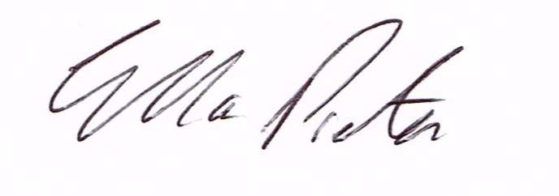

Mrs. E.Preston
Acting Clerk to the Parish Council
AGENDA

0) Public participation (maximum 15 minutes)
1) Apologies for absence
2) Declaration of Interests
The Localism Act 2011, Relevant Authorities (Disclosable Pecuniary Interests) Regulations 2012.
Members are reminded that they are required to leave the room during the discussion and voting on matters in which they have a disclosable pecuniary interest, whether or not the interest is entered in the register of member’s interests maintained by the Monitoring Officer.

3) To confirm minutes of the meeting held on 28th November 2016 (copy attached)
4) Matters Arising from the minutes
(a) Progress report from Clerk (distributed at meeting)
(b) Any other matters arising
5) Planning applications/permissions/refusals: Planning permissions granted:
Reference: 16/03894/FUL (validated: 13/09/2016)
Address: Braggins Lye, Chorley, Bridgnorth, Shropshire, WV16 6PP
Proposal: Erection of extension and internal alterations
Decision: Grant Permission
Reference: 16/05315/CPL (validated: 01/12/2016) Address:
The Barns High Street, Stottesdon. Proposal: Application for Lawful Development
Certificate to extend 0.9 high Boundary Picket Fence. Installation of a ground floor
Casement window. Applicant: Mr. Terence Montague.
Reference: 16/05465/FUL (validated: 12/12/2016)
Address: Proposed Residential Development Land To The North Of, Station Road,
Stottesdon, Shropshire
Proposal: Erection of 3No dwellings and garaging for those dwellings and Whiteside
Bungalow following demolition of existing but redundant farm buildings –
Applicant: TB & R Griffiths (Mr Ben Griffiths, Whiteside Bungalow, Station Road,
STOTTESDON, DY14 8TT)

.
a) Any received after issue of the agenda
Any others received after issue of the agenda
6) Precept – To be finalised at January meeting.
7) To confirm residency requirements for affordable housing to Planning Department –
Mr.Dorrell.
8) Unitary Councillor’s report
9) Financial matters:
a) Outstanding payments:
Clerk’s salary (bank transfer), HMRC PAYE,
Any other accounts received after issue of the agenda
b) Income since last meeting - confirmed at meeting
10) Parish matters/problems
a) Parish problems
b) Parish Watch
11) Correspondence:
Emails forwarded include:
Connecting Shropshire broadband update
SALC - Planning Services Briefing Note: Managing Planning Enforcement Enquiries
SALC - Elections Update
Severn Centre, Highley - Enter Miners' Trial 2017 (Shropshire Sprint Triathlon)
Shropshire Open Space Needs Assessment
Cleobury Country - Emergency First Aid at Work - 26.01.17 - BOOK NOW!!
Pension – Clerk
Severn Centre, Highley - Fitness Day 21st January
NALC Bulletin - Important please read
SALC - Media Release: Statement about NHS Future Fit Programme Board
Recommendation
Cleobury Country Course Schedule 2017
Shropshire Telford and Wrekin Sustainability and Transformation Plan
Parish and Town Council Strategic Freight Study - Marches LEP
SALC - Important - Update Briefing on the Local Plan Review
SALC - Active Places Convention
SALC - Grants and Funding!!
Road to be closed: Yew Tree Farm to Ferny Hall, Rays Bridge, High Green – 21/2/17-8/3/17
Machine surfacing with minor civil works.
Any other correspondence received after issue of agenda
12) SALC Report
13) Date of next meeting: 24th January 2017
14) Councillor Approval for Absence

