Stottesdon and Sidbury Parish Council
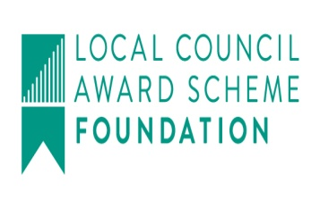
Clerk: Mrs Freda Morris
18 Glebe Drive
Stottesdon
Kidderminster
Worcs
DY14 8UF

Telephone: 01746 718453
E-mail: stottesdonpc@btinternet.com
Website: www.stottesdonpc.co.uk

Date: 5th May 2017

To: All Parish Council members
The Public and Press

Annual Parish Council meeting will be held on MONDAY 15th MAY 2017 at 7.30pm in CHORLEY VILLAGE HALL for the transaction of business as set out in the agenda below which you are summoned to attend.

It would help if you could arrive as earlier as possible in order that Declaration of Acceptance of Office forms can be completed prior to the meeting commencing.

Yours sincerely
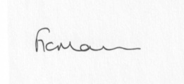
Mrs F Morris
Clerk to the Parish Council

AGENDA
1) Election of Officers:
Chairman
Vice Chairman
Committees – as considered necessary
School Governor representative
2) Public participation (maximum 15 minutes) The meeting will be suspended for this item
3) Apologies for absence
4) Declaration of Interests
The Localism Act 2011, Relevant Authorities (Disclosable Pecuniary Interests) Regulations 2012.
Members are reminded that they are required to leave the room during the discussion and voting on matters in which they have a disclosable pecuniary interest, whether or not the interest is entered in the register of member’s interests maintained by the Monitoring Officer.
5) To confirm minutes of the meeting held on 24th April 2017 (copy attached)
6) Matters Arising from the minutes
(a) Progress report from Clerk (distributed at meeting)
SC - Parish problems response
(b) any other matters arising
7) Planning applications/permissions/refusals:
a) Any received after issue of the agenda
8) SALC report
9) Unitary Councillor’s report
10) Financial matters
a) Outstanding payments:
Clerk’s salary (bank transfer), HMRC PAYE. Insurance renewal, SALC account
Any other accounts received after issue of the agenda
b) Income since last meeting – SC precept
c) Bank statement
d Accounts/Audit
11) Parish matters/problems
a) Parish problems
b) Parish Watch
c) Fox and Hounds car park update
d) Local lettings policy – STAR Housing
12) Correspondence:
Emails forwarded include:
Elections update
SALC Bulletins
SC - Broadband update from Ben Walker
Came and Co – Insurance Renewal Invitation
SC - End of Moratorium The Old Car Park at the Closed Fox and Hounds, Stottesdon
SC – Certificate of Lawfulness - Factory farm planning response
Dog fouling complaint
Alterations to the electoral register
Any other correspondence received after issue of agenda
13) Date of next meeting: 26th June 2017

