
Stottesdon and Sidbury Parish Council
Clerk: Mrs Freda Morris
18 Glebe Drive
Stottesdon
Kidderminster
Worcs
DY14 8UF

Telephone: 01746 718453
E-mail: stottesdonpc@btinternet.com
16th November 2010

To all members of Personnel Committee

There will be a Personnel Committee meeting on Monday 22nd November at 6.30pm prior to the Parish Council meeting at Chorley Village Hall for the transaction of the business as set out below:

Yours sincerely

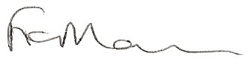

Mrs F Morris
Clerk to the Parish Council

AGENDA:

1. Apologies
2. Minutes of last meeting held on 28th June 2010
3. Declarations of interest
4. To confirm Staff appraisal
6. Salary/hours
7. Date of next meeting

Due to the confidential nature of the business to be discussed the public and press shall be excluded under s1(2) Public Bodies (Admission to Meetings) Act 1960.

