STOTTESDON AND SIDBURY PARISH COUNCIL
The ANNUAL PARISH MEETING will be held at the Old Vicarage Adventure Centre, Stottesdon on MONDAY APRIL 19th 2010 at 7.30pm.
Local Government electors for the Parish will be entitled to vote at the meeting which will be open to the public.

Mr Anthony Eddies-Davies will give a short presentation regarding the facilities that the Old Vicarage Adventure Centre offers.
Emma-Jane Ellison, Shropshire Council Emergency Planning Officer will also give a short presentation regarding the work of the Emergency Planning Department and how the department acts in the event of emergencies.

Agenda:

01. Apologies
02. Minutes of last meeting – April 20th 2009 (copy attached)
03. Mr Anthony Eddies-Davies – Old Vicarage Adventure Centre
04. Emma-Jane Ellison, Shropshire Council Emergency Planning Officer
05. Matters arising from minutes:
Dog fouling – update given at meeting
Speeding vehicles – update given at meeting
06. Chairman’s Annual Report
07. Organisation reports:
a) Stottesdon School Governors b) WI
c) Charity Trustees d) Playgroup
e) Chorley Village Hall f) Parish Watch
g) SWAG h) Parish Plan update
i) Youth Club j) Stotty Strolls
k) Nightingale Nurses
08. Parish problems
09. Shropshire Councillor’s report
10. Chairman’s closing comments
11. Date of next meeting

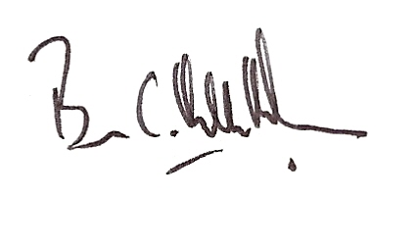
Brian Hamilton-Russell
Chairman – Stottesdon and Sidbury Parish Council

10th April 2010

