Stottesdon and Sidbury Parish Council
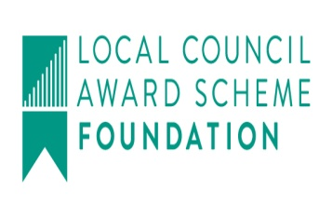
Clerk: Mrs Freda Morris
18 Glebe Drive
Stottesdon
Kidderminster
Worcs
DY14 8UF

Telephone: 01746 718453
E-mail: stottesdonpc@btinternet.com
Website: www.stottesdonpc.co.uk

Date: 23rd October 2017
To: All Parish Council members
The Public and Press

A Parish Council meeting will be held on MONDAY 30th OCTOBER 2017 at 7.30pm in CHORLEY VILLAGE HALL for the transaction of business as set out in the agenda below which you are summoned to attend.

Yours sincerely
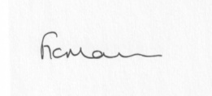
Mrs F Morris
Clerk to the Parish Council

AGENDA

0) Public participation (maximum 15 minutes)
1) Apologies for absence
2) Declaration of Interests
The Localism Act 2011, Relevant Authorities (Disclosable Pecuniary Interests) Regulations 2012.
Members are reminded that they are required to leave the room during the discussion and voting on matters in which they have a disclosable pecuniary interest, whether or not the interest is entered in the register of member’s interests maintained by the Monitoring Officer.
3) To confirm minutes of the meeting held on 25th September and extra ordinary meeting 10th October (copy attached)
4) Car parking outside Stottesdon School
5) Fox and Hounds car park update to include Reply from Insurance Company and Surveyor quotes
6) Matters Arising from the minutes
(a) Progress report from Clerk (distributed at meeting)
(b) any other matters arising
(c) Dog mess bin update
7) Broadband provision in Chorley Village Hall update
8) Planning applications/permissions/refusals:
a) Reference: 17/03871/FUL (validated: 23/08/2017)
Address: Stanley Farm, Chorley, Bridgnorth, Shropshire, WV16 6PS
Proposal: Erection of a steel portal frame agricultural building for the housing of calves
Decision: Grant Permission

b) Any others received after issue of agenda
9) SALC report
10) Unitary Councillor’s report
11) Financial matters:
a) To confirm bank transfer payments from last month
b) Outstanding payments:
Clerk’s salary (bank transfer), HMRC PAYE (bank transfer), SC – Election charge (payable next year)
Any other accounts received after issue of the agenda
c) Income since last meeting - confirmed at meeting
d) Bank statement/new bank signatories/bank reconciliation
e) Request for donation – Samaritans
12) Parish matters/problems
a) Parish problems:
b) Parish Watch
c) Parish newsletter
d) Lengthsman Scheme applicantions
e) Stottesdon School Governor
f) Provision of defibrillator
13) Correspondence:
Emails forwarded include:
SALC Bulletins
SOUTH SHROPSHIRE YOUTH FORUM AGM 16th Nov 7pm, Rockspring Centre, Ludlow, SY8 1SX
SALC – Consultation – Planning for the right home in the right place
Cleobury Country training sessions:
- CIEH Foundation Certificate in Occupational Health & Safety - 17th October 2017
- 3 x Day First Aid at Work Course - 13,14,15 November 2017
- Emergency First Aid – 9th November 9am-4pm
- Fill the Fridge Networking Event - 16th November
- PAT Testing – 28th November 9am-4.30pm
SALC – training events
- Briefing on Key Changes under General Data Protection Regulations - Wednesday 8th November 2017, 5.30pm - 7.30pm at Shirehall, Abbey Foregate, Shrewsbury SY2 6ND
- Insurance for Town and Parish Councils training - Rescheduled to Wednesday 29th November 2017 (originally scheduled for 13th September)
- Councils as Employers training - 6th November 2017, 10am - 4pm at Shirehall, Abbey Foregate, Shrewsbury SY2 6ND
Any other correspondence received after issue of agenda
14) Date of next meeting: Monday 27th November 2017

