Stottesdon and Sidbury Parish Council
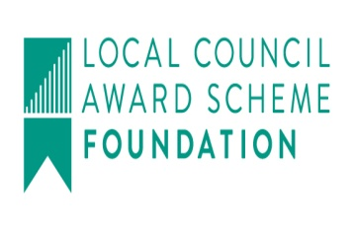
Clerk: Mrs Freda Morris
18 Glebe Drive
Stottesdon
Kidderminster
Worcs
DY14 8UF

Telephone: 01746 718453
E-mail: stottesdonpc@btinternet.com
Website: www.stottesdonpc.co.uk

Date: 20th November 2017
To: All Parish Council members
The Public and Press

A Parish Council meeting will be held on MONDAY 27th NOVEMBER 2017 at 7.30pm in CHORLEY VILLAGE HALL for the transaction of business as set out in the agenda below which you are summoned to attend.

Yours sincerely
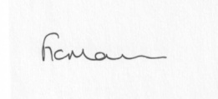
Mrs F Morris
Clerk to the Parish Council

AGENDA

0) Public participation (maximum 15 minutes)
1) Apologies for absence
2) Declaration of Interests
The Localism Act 2011, Relevant Authorities (Disclosable Pecuniary Interests) Regulations 2012.
Members are reminded that they are required to leave the room during the discussion and voting on matters in which they have a disclosable pecuniary interest, whether or not the interest is entered in the register of member’s interests maintained by the Monitoring Officer.
3) To confirm minutes of the meeting held on 30th October and extra ordinary meeting 14th November (copy attached)
4) Car parking outside Stottesdon School – any update received
5) Fox and Hounds car park update to include Reply from Insurance Company and Surveyor quotes – any update received
6) Matters Arising from the minutes
(a) Progress report from Clerk (distributed at meeting)
(b) any other matters arising
7) Broadband provision in Chorley Village Hall update
8) Planning applications/permissions/refusals:
a) Reference: 17/03102/FUL (validated: 30/06/2017)
Address: Firien Barn, Lower Bardley Court, Stottesdon, Kidderminster, Shropshire, DY14 8NE
Proposal: Erection of single storey front extension
Decision: Withdrawn
b) Any others received after issue of agenda
9) SALC report
10) Unitary Councillor’s report
11) Financial matters:
a) To confirm bank transfer payments from last month
b) Outstanding payments:
Clerk’s salary (bank transfer), HMRC PAYE (bank transfer), SALC – training account
Any other accounts received after issue of the agenda
c) Income since last meeting - confirmed at meeting
d) Bank statement
12) Parish matters/problems
a) Parish problems:
b) Parish Watch
c) Lengthsman Scheme update
13) Correspondence:
Emails forwarded include:
SALC Bulletins
SALC - Local older people asked to share stories of stressful hospital journeys
Vicky Turner - Local Plan Review - Preferred Options Consultation
Police.uk] New data published for September 2017
General Data Protection Regulations - A Helpful 20 Document Pack - £30+VAT
SALC – training events – confirmed at meeting
Cleobury Country training events:
PAT Testing Training Certificate – 28th November 9-4pm £195+VAT
Get Ready for General Data Protection Regulation - Workshop - 12.12.17 - £50 + VAT
Any other correspondence received after issue of agenda
14) Date of next meeting: Monday 18th December 2017

