Stottesdon and Sidbury Parish Council
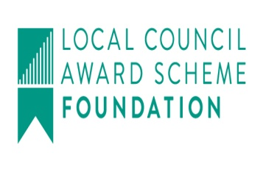
Clerk: Mrs Freda Morris
18 Glebe Drive
Stottesdon
Kidderminster
Worcs
DY14 8UF

Telephone: 01746 718453
E-mail: stottesdonpc@btinternet.com
Website: www.stottesdonpc.co.uk

Date: 20th March 2017

To: All Parish Council members
The Public and Press

A Parish Council meeting will be held on MONDAY 27th MARCH 2017 at 7.30pm in CHORLEY VILLAGE HALL for the transaction of business as set out in the agenda below which you are summoned to attend.

Yours sincerely
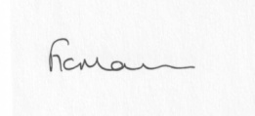
Mrs F Morris
Clerk to the Parish Council

AGENDA

0) Public participation (maximum 15 minutes)
1) Apologies for absence
2) Declaration of Interests
The Localism Act 2011, Relevant Authorities (Disclosable Pecuniary Interests) Regulations 2012.
Members are reminded that they are required to leave the room during the discussion and voting on matters in which they have a disclosable pecuniary interest, whether or not the interest is entered in the register of member’s interests maintained by the Monitoring Officer.
3) To confirm minutes of the meeting held on 1st March 2017 (copy attached)
4) Matters Arising from the minutes
(a) Progress report from Clerk (distributed at meeting)
(b) any other matters arising
5) Planning applications/permissions/refusals:
Applications:
a) Reference: 17/00793/FUL
Address: Pickthorn Farm, Chorley, Bridgnorth, WV16 6PU
Proposal: Erection of a silage pit formed of concrete wall panels

b) 17/00687/TCA – Tree removal, Rose Bank, Stottesdon - any update
c) Any received after issue of the agenda
6) SALC report
7) Unitary Councillor’s report (if any)
8) Financial matters:
a) Outstanding payments:
Clerk’s salary (bank transfer), HMRC PAYE, Clerk’s expenses, Crucial Crew donation receipt. Cleobury IT Solutions Website Domain name renewal. SALC account – Good Councillors Guide and Charles Arnold Baker Book. PWLB Repayment Notice (Glebe Drive), Burial Grants/Donations, Willowdene account.
Any other accounts received after issue of the agenda
b) Income since last meeting - confirmed at meeting
c) Bank statement
9) Parish matters/problems
a) Parish problems
b) Parish Watch
c) Fox and Hounds car park update/decision
d) Elections
10) Correspondence:
Emails forwarded include:
SALC Bulletins
Alterations to the electoral register
Community School Governor representative – Stottesdon Primary School
Highway Maintenance scheme
ALC - Town and Parish Council Neighbourhood Plans - April 2017
Shropshire Council's review of the Local Plan - one week left to submit your response!
Cleobury Country - NEW COURSE!! ❇ AAT Foundation Award in Accounting Software
SALC - Introduction to Business Planning - Top Ten Tips 3rd April 2017, CHANGE OF VENUE - NOW 10am - 1pm at LAWLEY & OVERDALE PARISH COUNCIL Leonard Smith Way, Lawley TF3 5HT
SALC - Healthwatch Shropshire supports Experience of Care Week
Cleobury Country - Level 2 Award in the Principles of COSHH - 04.04.17 - BOOK NOW!!
SALC - Economic Growth Strategy Consultation
Brown Clee Patient Participation Group meeting – 10th April 2017
Any other correspondence received after issue of agenda
11) Date of next meeting: 10th April - Annual Parish meeting and 24th April - Parish Council meeting

Please note:
Deadline for newsletter articles is
12 noon 24th March 2017
Please keep articles to a maximum of 200 words

