Stottesdon and Sidbury Parish Council
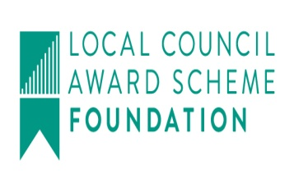
Clerk: Mrs Freda Morris
18 Glebe Drive
Stottesdon
Kidderminster
Worcs
DY14 8UF

Telephone: 01746 718453
E-mail: stottesdonpc@btinternet.com
Website: www.stottesdonpc.co.uk

Date: 16th June 2018
To: All Parish Council members
The Public and Press

A Parish Council meeting will be held on MONDAY 25th JUNE 2018 at 7.30pm in CHORLEY VILLAGE HALL for the transaction of business as set out in the agenda below which you are summoned to attend.

Yours sincerely
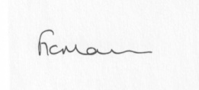
Mrs F Morris
Clerk to the Parish Council

AGENDA

0) Public participation (maximum 15 minutes)
1) Apologies for absence
2) Resignation Cllr J Hill
3) Declaration of Interests
The Localism Act 2011, Relevant Authorities (Disclosable Pecuniary Interests) Regulations 2012.
Members are reminded that they are required to leave the room during the discussion and voting on matters in which they have a disclosable pecuniary interest, whether or not the interest is entered in the register of member’s interests maintained by the Monitoring Officer.
4) To confirm minutes of the meeting held on 21st May 2018 (copy attached)
5) Matters Arising from the minutes
(a) Progress report from Clerk (distributed at meeting):
Reply re: recycling banks at Station Road, Stottesdon
Came and Company - Playground Equipment at Chorley Chapel
(b) any other matters arising
6) Fox and Hounds car park update
7) Planning applications/permissions/refusals:
a) Reference: 18/01439/CPE (validated: 26/04/2018)
Address: New House Farm, Bagginswood, Stottesdon, Kidderminster, DY14 8LU
Proposal: Application for Lawful Development Certificate for the existing use of former agricultural building as a commercial joinery workshop
Decision: Withdrawn
b) Any others received after issue of agenda
8) SALC report
9) Unitary Councillor’s report
10) Financial matters:
a) To confirm bank transfer payments from last month
b) Outstanding payments:
Clerk’s salary (bank transfer), Clerk’s expenses, HMRC PAYE (bank transfer), Zen (broadband in village hall) - £36. NALC – Local Council Review subscription, SC – Election costs. Web Orchard – new website. Viking Account. Any other accounts received after issue of the agenda
c) Income since last meeting - confirmed at meeting
d) Bank statement
11) Audit:
a) To approve accounts in Cash Book
b) To consider Internal Auditor’s report
c) Approval of Section 1 – Annual Governance Statement 2017-18
d) Approval of Section 2 – Accounting Statements 2017-18
12) Parish matters/problems
a) Parish problems
b) Parish Watch
c) Lengthsman Scheme update
13) Correspondence:
Emails forwarded include:
The verge on the Church drive.
Community Enablement Officers
Public meeting – 26th June 7pm Kinlet Village Hall – Health and Highways
SALC:
- Bulletins
- Queens Award for Voluntary service
- Data Protection Fees
- Free breakfast briefing - when things go wrong (disciplinary and capability) – 11th July
- Making a beneficial difference - Training for new Mayors, Deputies and staff supporting Mayors - Friday 29th June 2018, 5.30pm - 7.30pm at Shirehall, Shrewsbury
- 2DLaw – 29th June (appointments only)
- Negotiate a Better Outcome in Planning - Wednesday 12th September 2018, 10am - 4pm at The Lord Hill Hotel, Abbey Foregate, Shrewsbury
- NALC Chief executive's bulletin
Any other correspondence received after issue of agenda
14) Policy updates:
- Standing orders/Financial Regulations
15) Date of next meeting: Monday 23rd July 2018

