Stottesdon and Sidbury Parish Council
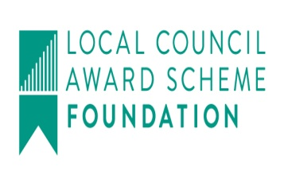
Clerk: Mrs Freda Morris
18 Glebe Drive
Stottesdon
Kidderminster
Worcs
DY14 8UF

Telephone: 01746 718453
E-mail: stottesdonpc@btinternet.com
Website: www.stottesdonpc.co.uk

Date: 16th October 2016

To: All Parish Council members
The Public and Press

A Parish Council meeting will be held on MONDAY 24th OCTOBER 2016 at 7.30pm in CHORLEY VILLAGE HALL for the transaction of business as set out in the agenda below which you are summoned to attend.

Yours sincerely
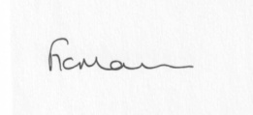
Mrs F Morris
Clerk to the Parish Council

AGENDA

0) Public participation (maximum 15 minutes)
1) Apologies for absence
2) Casual Vacancy:
a) to appoint new Councillor
b) Signing of declaration of acceptance of office
3) Declaration of Interests
The Localism Act 2011, Relevant Authorities (Disclosable Pecuniary Interests) Regulations 2012.
Members are reminded that they are required to leave the room during the discussion and voting on matters in which they have a disclosable pecuniary interest, whether or not the interest is entered in the register of member’s interests maintained by the Monitoring Officer.
4) To confirm minutes of the meeting held on 26TH September 2016 (copy attached)
5) Matters Arising from the minutes
(a) Progress report from Clerk (distributed at meeting)
(b) any other matters arising
6) Planning applications/permissions/refusals:
a) Reference: 16/03453/LBC (validated: 03/08/2016)
Address: Hall Farm House, Sidbury, Bridgnorth, Shropshire, WV16 6PY
Proposal: Replacement of 7 x timber windows with 7 x new hardwood double glazed windows to match existing to Grade II listed farmhouse (amended description)
Decision: Grant Permission
b) Any received after issue of the agenda
7) SALC report
8) Unitary Councillor’s report
9) Financial matters:
a) Outstanding payments:
Clerk’s salary (bank transfer), HMRC PAYE, Data Protection registration - Reminder to renew ICO:00043610216
Any other accounts received after issue of the agenda
b) Income since last meeting - confirmed at meeting
c) Bank statement/Bank Signatories
d) Quarterly bank reconciliation
e) Samaritans - Application for Grant
f) Precept – reminder that this needs looking into Nov/Dec
10) Parish matters/problems
a) Parish problems
b) Parish Watch
11) Correspondence:
Emails forwarded include:
SALC Bulletins
Alterations to the electoral register
Cleobury Country - Level 2 Award in Health and Safety - CIEH approved - 09.11.16
Future Fit - An explanation of the facts behind the headlines on NHS Future Fit
Future Fit - Health leaders to consider location for the Emergency Centre
Cleobury Country - 3 x Day First Aid at Work Course - 14,15,16 November 2016
SALC – Futurefit
Vicky Turner - Public Open Spaces (Mark Blount, SC manager of Public Open Spaces requested this as an agenda item for November meeting)
Shropshire Outdoor Partnerships Newsletter - Summer 2016
SC - Shropshire Council's Community Tree Scheme
Cleobury Country - Portable Appliance Testing - 10th November 2016
Cleobury Country - Emergency First Aid at Work - 24th November 2016
Healthwatch Shropshire Annual Event
SALC - AGM and Conference 2016
Severn Valley Country Park Bulletin October 2016
Footpath from Glebe Drive to the Church – telephone calls from Mrs Livesey and email from Steve Watkins
Council Matters Autumn 2016 - Came & Company Local Council Insurance Brokers
Any other correspondence received after issue of agenda
12) Date of next meeting: 28th November 2016

