Stottesdon and Sidbury Parish Council
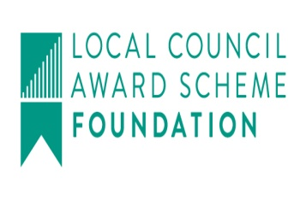
Clerk: Mrs Freda Morris
18 Glebe Drive
Stottesdon
Kidderminster
Worcs
DY14 8UF

Telephone: 01746 718453
E-mail: stottesdonpc@btinternet.com
Website: www.stottesdonpc.co.uk

Date: 16th July 2018
To: All Parish Council members
The Public and Press

A Parish Council meeting will be held on MONDAY 23rd JULY 2018 at 7.30pm in CHORLEY VILLAGE HALL for the transaction of business as set out in the agenda below which you are summoned to attend.

Yours sincerely
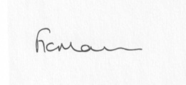
Mrs F Morris
Clerk to the Parish Council

AGENDA

0) Public participation (maximum 15 minutes)
1) Apologies for absence
2) Co-option of new Councillor confirmation from SC
3) Signing of acceptance of office for new Cllr
4) Declaration of Interests
The Localism Act 2011, Relevant Authorities (Disclosable Pecuniary Interests) Regulations 2012.
Members are reminded that they are required to leave the room during the discussion and voting on matters in which they have a disclosable pecuniary interest, whether or not the interest is entered in the register of member’s interests maintained by the Monitoring Officer.
5) To confirm minutes of the meeting held on 25th June 2018 (copy attached)
6) Matters Arising from the minutes
(a) Progress report from Clerk (distributed at meeting):
Reply rom SC re: road repairs
(b) any other matters arising
7) Planning applications/permissions/refusals:
a) Reference: 18/03008/HRM (validated: 28/06/2018)
Address: Land Near Lower Northwood Farm, Northwood Lane, Northwood, Chorley, Bridgnorth, Shropshire, WV16 6PT
Proposal: To remove three consecutive sections of hedgerow totalling 88m to improve workability of fields on land east of Lower Northwood Farm.
Applicant: Mr Michael Fletcher (Greenacres, Stottesdon, Kidderminster, Shropshire, DY14 8ND)
b) Any others received after issue of agenda
8) SALC report
9) Unitary Councillor’s report
10) Financial matters:
a) To confirm bank transfer payments from last month
b) Outstanding payments:
Clerk’s salary (bank transfer), HMRC PAYE (bank transfer), Zen (broadband in village hall), Web Orchard – new website. Invar Mapping (marking out of car park), Lengthsman Scheme account. Any other accounts received after issue of the agenda
c) Income since last meeting - confirmed at meeting
d) Bank statement/reconciliation
11) Parish matters/problems
a) Parish problems
b) Parish Watch
c) Lengthsman Scheme update
12) Correspondence:
Emails forwarded include:
SALC:
- Bulletins
- Negotiate a Better Outcome in Planning - Wednesday 12th September 2018, 10am - 4pm at The Lord Hill Hotel, Abbey Foregate, Shrewsbury
- Fundamentals for Councillors training - Wednesday 26th September 2018, 5.30pm - 7.30pm at Shirehall, Abbey Foregate, Shrewsbury
- CONSULTATION: Shropshire Council Statement of Licensing Policy 2019 – 2024
- Shropshire Council Discretionary Rate Relief Policy review
- Vicky Turner - Presentations from recent LJC Public Meeting
- Cleobury Country - CIEH Foundation Certificate in Occupational Health & Safety - 17th October 2018
Any other correspondence received after issue of agenda
13) Policy updates:
- Standing orders/Financial Regulations
14) Old Fox and Hounds car park update/review***
15) Date of next meeting: Monday 20th August 2018

*** Item 14:
That under the Public Bodies (Admission to Meetings) Act 1960, the public and representatives of the press and broadcast media be excluded from the meeting during the consideration of the following items of business as publicity would be prejudicial to the public interest because of the confidential nature of the business to be transacted

