Stottesdon and Sidbury Parish Council

Clerk: Mrs Freda Morris
18 Glebe Drive
Stottesdon
Kidderminster
Worcs
DY14 8UF

Telephone: 01746 718453
E-mail: stottesdonpc@btinternet.com
Website: www.stottesdonpc.co.uk

Date: 15th January 2017
To: All Parish Council members
The Public and Press

A Parish Council meeting will be held on MONDAY 23rd January 2017 at 7.30pm in CHORLEY VILLAGE HALL for the transaction of business as set out in the agenda below which you are summoned to attend.

Yours sincerely
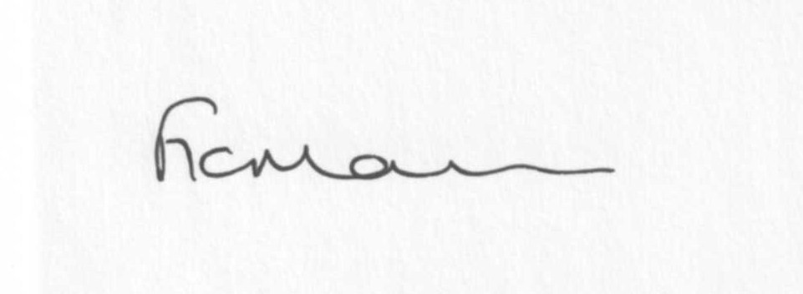
Mrs Freda Morris
Clerk to the Parish Council

AGENDA

0) Public participation (maximum 15 minutes)
1) Apologies for absence
2) Declaration of Interests
The Localism Act 2011, Relevant Authorities (Disclosable Pecuniary Interests) Regulations 2012.
Members are reminded that they are required to leave the room during the discussion and voting on matters in which they have a disclosable pecuniary interest, whether or not the interest is entered in the register of member’s interests maintained by the Monitoring Officer.
3) To confirm minutes of the meeting held on 19th December 2016 (copy attached)
4) Matters Arising from the minutes
(a) Progress report from Clerk (distributed at meeting)
(b) Any other matters arising
5) Planning applications/permissions/refusals:
a) Reference: 16/05716/OHL (validated: 16/12/2016)
Address: Pickthorn Farm, Chorley, Bridgnorth, Shropshire, WV16 6PU
Proposal: Installation of third wire to 2no existing overhead lines using existing support positions
Applicant: Western Power Distribution (C/o Agent)

b) Reference: 16/05315/CPL (validated: 01/12/2016)
Address: The Barns , High Street, Stottesdon, DY14 8UJ
Proposal: Application for Lawful Development Certificate to extend 0.9m high boundary picket fencing; Installation of a ground floor casement window.
Decision: Withdrawn

c) Reference: 16/05821/FUL (validated: 09/01/2017)
Address: The Barns, High Street, Stottesdon, Shropshire, DY14 8TZ
Proposal: Installation of a ground floor casement window with obscure glazing; Extend existing 0.9m high boundary picket fencing
Applicant: Mr Terence Montague

d) Reference: 16/05799/FUL (validated: 21/12/2016)
Address: Pickthorn Farm, Chorley, Bridgnorth, Shropshire, WV16 6PU
Proposal: Erection of a portal steel framed cattle building
Applicant: MP Abbiss (Mr Russell Abbiss, Pick thorn Farm, Chorley, Bridgnorth, Shropshire, WV16 6PU)

e) Reference: 16/05800/FUL (validated: 21/12/2016)
Address: Pickthorn Farm, Chorley, Bridgnorth, Shropshire, WV16 6PU
Proposal: Erection of a portal steel framed cattle building
Applicant: MP Abbiss (Mr Russell Abbiss, Pickthorn Farm, Chorley, Bridgnorth, Shropshire, WV16 6PU)

f) Reference: 16/05801/FUL (validated: 21/12/2016)
Address: Pickthorn Farm, Chorley, Bridgnorth, Shropshire, WV16 6PU
Proposal: Erection of portal steel framed end extension to existing cattle building and additional canopy to existing building
Applicant: MP Abbiss

g) Reference: 16/05274/OHL (validated: 16/11/2016)
Address: Bardley Cottage, Stottesdon, Kidderminster, Shropshire, DY14 8NF
Proposal: Upgrade an existing 2 wire 11,000 volt circuit to 3 wire 11,000 volts to provide a supply to one customer
Decision: No Objection OHL/Circular Notification

h) Any received after issue of the agenda
6) Precept
7) Financial matters:
a) Outstanding payments:
Clerk’s salary (bank transfer), HMRC PAYE, Viking Direct, Mrs E Preston (Locum Clerk account), SLCC subs renewal.
Any other accounts received after issue of the agenda
b) Income since last meeting - confirmed at meeting
c) Clerk’s Pension/Salary
d) Quarterly Bank reconciliation
8) Unitary Cllr’s report
9) SALC report
10) Parish matters/problems
a) Parish problems
b) Parish Watch
11) Correspondence:
Emails forwarded include:
Connecting Shropshire broadband update
SALC - Shropshire Bus Strategy 2017-2021 - Public Consultation – comments required by 13/2/17
SALC - BATTLE'S OVER - A NATION'S TRIBUTE & WWI BEACONS OF LIGHT 11TH NOVEMBER 2018
Severn Valley Country Park Bulletin January 2017
Alterations to the electoral register
Cleobury Country - Fire Marshall Course - 9th February 2017 - BOOK NOW!!
SC - Road closure - Baveney Lane, Cleobury Mortimer 06/02/2017 – 9am – 3pm to locate and clear blockages
SALC - Elections training date re-arranged - new date Friday 17th February 2017, 9.30am - 12.30pm at Shirehall, Shrewsbury
SALC - Buckingham Palace Garden Party - 23rd May 2017
SC - Latest news on Shropshire roadworks
Cleobury Country - Social Media Strategy Course - Wednesday 1st February 2017 - BOOK NOW!!
SC - Annual Survey 2017
RSN - Rural Vulnerability Service - Rural Broadband - January 2017
Grounds Maintenance
Local connection letter – Mr M Dorrell
Letter from Will Evans re: litterpick in village for Duke of Edinburgh Award Scheme
Any other correspondence received after issue of agenda
12) Date of next meeting: - 27th February 2017 and to approve ‘provisional dates’ for next year

Confidential Item:
That under the Public Bodies (Admission to Meetings) Act 1960, the public and representatives of the press and broadcast media be excluded from the meeting during the consideration of the following items of business as publicity would be prejudicial to the public interest because of the confidential nature of the business to be transacted.

13) Asset of Community Value in Stottesdon – Action Plan

