Stottesdon and Sidbury Parish Council
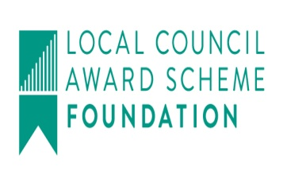
Clerk: Mrs Freda Morris
18 Glebe Drive
Stottesdon
Kidderminster
Worcs
DY14 8UF

Telephone: 01746 718453
E-mail: stottesdonpc@btinternet.com
Website: www.stottesdonpc.co.uk

Date: 10th December 2017
To: All Parish Council members
The Public and Press

A Parish Council meeting will be held on MONDAY 18th DECEMBER 2017 at 7.30pm in CHORLEY VILLAGE HALL for the transaction of business as set out in the agenda below which you are summoned to attend.

Yours sincerely
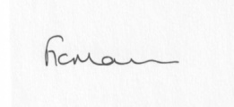
Mrs F Morris
Clerk to the Parish Council

AGENDA

**The public and press will be excluded for item 12.

0) Public participation (maximum 15 minutes)
1) Apologies for absence
2) Declaration of Interests
The Localism Act 2011, Relevant Authorities (Disclosable Pecuniary Interests) Regulations 2012.
Members are reminded that they are required to leave the room during the discussion and voting on matters in which they have a disclosable pecuniary interest, whether or not the interest is entered in the register of member’s interests maintained by the Monitoring Officer.
3) To confirm minutes of the meeting held on 27th November (copy attached)
4) Car parking outside Stottesdon School – any update received
5) Matters Arising from the minutes
(a) Progress report from Clerk (distributed at meeting)
(b) any other matters arising
6) Broadband provision in Chorley Village Hall update
7) Planning applications/permissions/refusals:
a) Reference: 17/03434/FUL (validated: 31/08/2017)
Address: Proposed Dwelling To The East Of, Bagginswood, Stottesdon, Shropshire
Proposal: Erection of one dwelling; detached double garage with external staircase to first floor office; installation of a package sewage treatment plant
Decision: Grant Permission
b) Any others received after issue of agenda
8) SALC report
9) Unitary Councillor’s report
10) Financial matters:
a) To confirm bank transfer payments from last month
b) Outstanding payments:
Clerk’s salary (bank transfer), HMRC PAYE (bank transfer), Information Commissioners Office Data Protection renewal
Any other accounts received after issue of the agenda
c) Income since last meeting - confirmed at meeting
d) Bank statement
11) Parish matters/problems
a) Parish problems:
b) Parish Watch
c) Lengthsman Scheme update
12) Fox and Hounds car park update/new Surveyor quotes **
13) Local Plan update
14) Correspondence:
Emails forwarded include:
SALC Bulletins
RSN Bulletins
Email from SC re: speeding complaint in Chorley
Any other correspondence received after issue of agenda
15) Date of next meeting: Monday 22nd January 2018

** That under the Public Bodies (Admission to Meetings) Act 1960, the public and representatives of the press and broadcast media be excluded from the meeting during the consideration of the following items of business as publicity would be prejudicial to the public interest because of the confidential nature of the business to be transacted.

