Stottesdon and Sidbury Parish Council
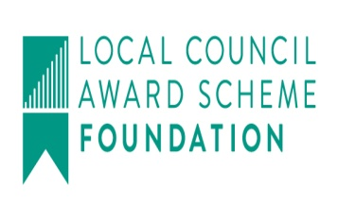
Clerk: Mrs Freda Morris
18 Glebe Drive
Stottesdon
Kidderminster
Worcs
DY14 8UF

Telephone: 01746 718453
E-mail: stottesdonpc@btinternet.com
Website: www.stottesdonpc.co.uk

Date: 7th November 2017

To: All Parish Council members
The Public and Press

An extra ordinary Parish Council meeting will be held on TUESDAY 14TH NOVEMBER 2017 at 7.30pm in CHORLEY VILLAGE HALL for the transaction of business as set out in the agenda below which you are summoned to attend.

Yours sincerely
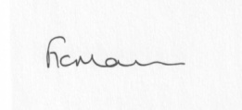
Mrs F Morris
Clerk to the Parish Council

AGENDA

0) Public participation (maximum 15 minutes)
1) Apologies for absence
2) Declaration of Interests
The Localism Act 2011, Relevant Authorities (Disclosable Pecuniary Interests) Regulations 2012.
Members are reminded that they are required to leave the room during the discussion and voting on matters in which they have a disclosable pecuniary interest, whether or not the interest is entered in the register of member’s interests maintained by the Monitoring Officer.
3) To confirm minutes of the extra ordinary meeting held on 10th October (copy previously circulated)
4) Quotes from Surveyors for work at old Fox and Hounds car park and to agree appointment
5) Date of next meeting – 27th November 2017, Chorley Village Hall

The public and press are cordially invited to attend

