
Stottesdon and Sidbury Parish Council
Clerk: Mrs Freda Morris
18 Glebe Drive
Stottesdon
Kidderminster
Worcs
DY14 8UF

Telephone: 01746 718453
E-mail: stottesdonpc@btinternet.com

Date: 21st June 2010
To: All Parish Council members
The Public and Press

A Parish Council meeting will be held on MONDAY 28th JUNE 2010 at 7.30pm in CHORLEY VILLAGE HALL for the transaction of business as set out in the agenda below.

Yours sincerely

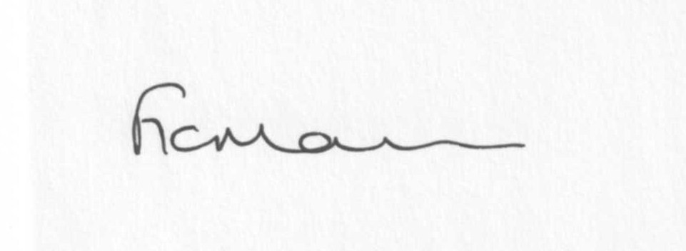

Mrs F Morris
Clerk to the Parish Council

AGENDA

0) Public participation
1) Apologies for absence
2) Declaration of Interests
“To receive declarations of Interest of personal and prejudicial interest on any item on the agenda in accordance with Section 50-52 of the Local Government Act & The Local Authorities (Model Code of Conduct) England Order 2001”.
3) To confirm minutes of the meeting held on 17th May 2010
4) Matters Arising from the minutes
(a) Progress report (list distributed at meeting)
SC reply re: comments on Poultry manure consultation document
Any others raised by Councillors
5) Planning applications:
a) Erection of a single storey extension-Lower Chorley Farm, Chorley
b) Application under Section73a of the Town & Country Planning Act for the
change of use from livery to workshop (retrospective) – Lower Chorley Farm,
Chorley
c) Erection of agricultural building for the storage of machinery, feed store and
animal (horse) shelter – Land adjacent Crown Cottages and opposite Roseacre,
Bagginswood
d) Works to facilitate rebuilding of rear gable elevation and chimney stack and
reinstatement of clay tiled roof to front elevation – Bagginswood Farm,
Bagginswood
e) Any others received after issue of agenda
f) Inspectorate’s report – The Firs, Billingsley Lane, Chorley
6) Correspondence:
SC – Road closure – Bagginswood/Kinlet road – 21st July for 2 days
SC – Road closure – Bagginswood/Six Ashes road – 30th August for 5 days
SC - Winter Maintenance
Wicksteed Leisure – Play equipment inspection
ALC Area Committee nomination papers – Chairman/Vice-chairman
SC – Posters re: Education and School organisation in the future
Any others received after the issue of the agenda
7) Follow up of meeting held on 16th June at Chorley Village Hall
8) Comments re: Health document – Single Equality sites (email previously forwarded)
9) Parish matters/problems
a) Parish problems
b) Parish Watch
c) Glebe Drive sign
d) Flashing Speed sign provision
10) Financial matters
a) Outstanding payments – Clerk’s salary. ALC account. PAYE. Any others received after issue of agenda.
b) Income since last meeting (list distributed at meeting)
c) Internal Audit
d) Personnel meeting report (verbal)
e) Internet banking
11) Newsletter delivery areas
12) ALC report**
13) Shropshire Councillor’s report
14) Items for next agenda
15) Date of next meeting – 26th July 2010

Please note deadline for newsletter articles
12 noon Friday 25th June.

**The ALC Area Committee AGM meeting is to be held on the 29th June 2010 at 7pm at Council Chambers, Westgate, Bridgnorth. This will include a Planning training session. Everyone is welcome to attend.

