
Stottesdon and Sidbury Parish Council
Clerk: Mrs Freda Morris
18 Glebe Drive
Stottesdon
Kidderminster
Worcs
DY14 8UF

Telephone: 01746 718453
E-mail: stottesdonpc@btinternet.com

Date: 6th June 2011
To: All Parish Council members
The Public and Press

A Parish Council meeting will be held on MONDAY 13th JUNE 2011 at 7.30pm in CHORLEY VILLAGE HALL for the transaction of business as set out in the agenda below.

**Due to the confidential nature of the business to be discussed under item 14 the public and press shall be excluded under s1(2) Public Bodies (Admission to Meetings) Act 1960.

Yours sincerely
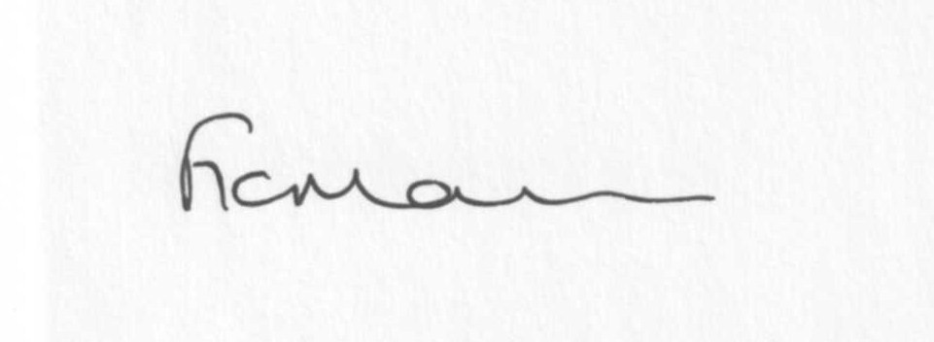
Mrs F Morris
Clerk to the Parish Council

AGENDA

0) Public participation
1) Apologies for absence
2) Declaration of Interests
“To receive declarations of Interest of personal and prejudicial interest on any item on the agenda in accordance with Section 50-52 of the Local Government Act & The Local Authorities (Model Code of Conduct) England Order 2001”.
3) To confirm minutes of the meeting held on 16th May 2011(copy attached)
4) Matters Arising from the minutes
(a) Progress report (distributed at meeting)
Any other matters
5) Casual Vacancy
6) Planning applications: a) Any received after issue of agenda
b) Planning approvals/refusals
7) Correspondence:
Friends of Shropshire Hills AONB
Severn Centre – What’s on in June
SLCC – Bookshop publications
Various emails forwarded – list updated at meeting
Any others received after the issue of the agenda
8) Parish matters/problems
a) Parish problems
b) Parish Watch
c) Lengthsman Scheme
d) School field update
9) Financial matters
a) Outstanding payments: Clerk’s fees. Localism Training event account.
LCR subscription renewal.
Accounts received after issue of agenda.
b) Income since last meeting (list distributed at meeting)
c) Internal Auditor’s report
d)Annual Return Audit form completion
e) Bank statement
10) Place Plans
11) Road works schedule – emailed out
12) ALC report
13) Shropshire Councillor’s report
14) Future Social Enterprise Scheme update**
15) Items for next agenda
16 Date of next meeting – 25th July 2011

Please note deadline for next newsletter is 12 noon 19th June 2011

