
Stottesdon and Sidbury Parish Council
Clerk: Mrs Freda Morris
18 Glebe Drive
Stottesdon
Kidderminster
Worcs
DY14 8UF

Telephone: 01746 718453
E-mail: stottesdonpc@btinternet.com

Date: 11th April 2011
To: All Parish Council members
The Public and Press

A Parish Council meeting will be held on MONDAY 18TH APRIL 2011 at 7.30pm in CHORLEY VILLAGE HALL for the transaction of business as set out in the agenda below.

Yours sincerely
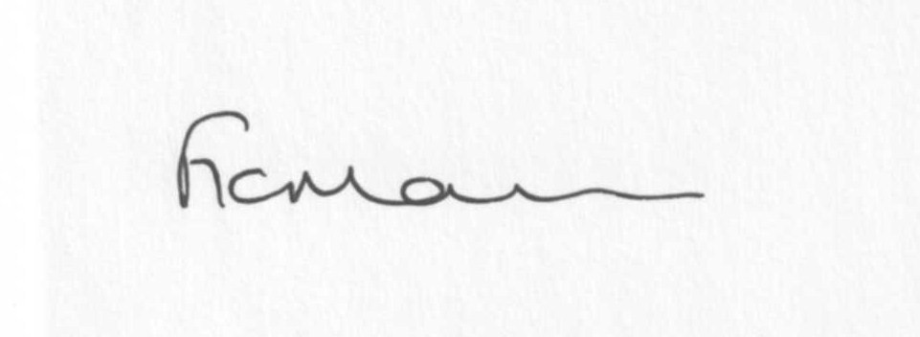
Mrs F Morris
Clerk to the Parish Council

AGENDA

0) Public participation
1) Apologies for absence
2) Declaration of Interests
“To receive declarations of Interest of personal and prejudicial interest on any item on the agenda in accordance with Section 50-52 of the Local Government Act & The Local Authorities (Model Code of Conduct) England Order 2001”.
3) To confirm minutes of the meeting held on 28TH March 2011(copy attached)
4) Matters Arising from the minutes
(a) Clerk’s Progress report
(b) Any other matters
5) Planning applications:
a) Erection of a glazed corridor link – Litley Oak, Chorley
b) Any others received after issue of agenda
c) Permissions/refusals
6) Correspondence:
Clerk’s new tax code
CAB )
Hope House )
Sidbury PC ) cheque acknowledgments
Parish online )
Chorley Chapel )
Severn Hospice )
Samaritans )
Chorley Village Hall )
Severn Centre )
SC – Precept confirmation
Any others received after issue of the agenda

Emails forwarded:
Weekly Planning lists
31/3 Public Service Efficiency update
31/3 ALC Parish Pump
4/4 ALC member training – bookings sent to Ian Kilby
4/4 ALC – Updated legal topics
4/4 SC – SamDev (paper copy received)
4/4 Rural Services Network newsletter
5/4 Journal of Local Planning – Budget 2011 changes
6/4 SC – supplementary Planning documents and list of active Local Plan policies
7/4 Public Services Efficiency update
7/4 SC – road closure Aston Botterell
7/4 SC- Places young people play
7/4 ALC – NALC E Bulletin 1/4/11 Consultation review of Statutory Duties
8/4 ALC – LJC community Action contacts April 2011
Any others received after the issue of the agenda
7) Website policy
8) Parish matters/problems
a) Parish problems
b) Parish Watch
9) School field drainage
10) Road name signs
11) Financial matters
a) Outstanding payments: Clerks fees, ALC subs, Insurance renewal. Any others received after issue of the agenda
b) Income since last meeting (list distributed at meeting)
c) Bank statement
d) Year end bank reconciliation
12) ALC report
13) Shropshire Councillor’s report
14) Items for next agenda
15) Date of next meeting - 23rd May Annual Parish Council meeting

