
Stottesdon and Sidbury Parish Council
Clerk: Mrs Freda Morris
18 Glebe Drive
Stottesdon
Kidderminster
Worcs
DY14 8UF

Telephone: 01746 718453
E-mail: stottesdonpc@btinternet.com

Date: 17th July 2014
To: All Parish Council members
The Public and Press

A Parish Council meeting will be held on MONDAY 28th JULY 2014, at 7.30pm in CHORLEY VILLAGE HALL for the transaction of business as set out in the agenda below which you are summoned to attend.
Matt Home and Dave Walker, Willowdene will attend re: Lengthsman Scheme

Yours sincerely

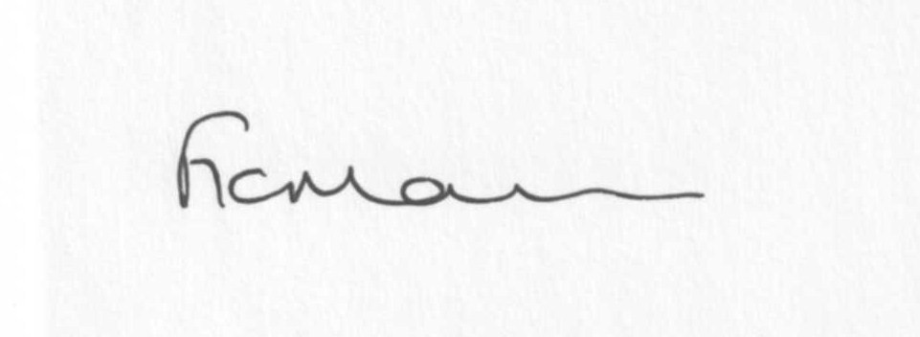
Mrs F Morris
Clerk to the Parish Council

AGENDA

0) Public participation (maximum 15 minutes)

1) Apologies for absence
2) Declaration of Interests
The Localism Act 2011, Relevant Authorities (Disclosable Pecuniary Interests) Regulations 2012.
Members are reminded that they are required to leave the room during the discussion and voting on matters in which they have a disclosable pecuniary interest, whether or not the interest is entered in the register of member’s interests maintained by the Monitoring Officer.
3) To confirm minutes of the meeting held on June 23rd 2014 (copy attached)
4) Matters Arising from the minutes
(a) Progress report (distributed at meeting)
(b) Reply from SC re; parish problems
(c) Any other matters arising
5) Planning applications:
a1) Reference: 14/02658/FUL (validated: 18/06/2014)
Address: Mass House Farm, Stottesdon, Kidderminster, DY14 8NL
Proposal: Installation of a ground mounted solar panels
Applicant: Xebec Investments (7 Oak Court, Woodlands, Grouville, Jersey, JE3 9AW)

A2) Reference: 14/02898/FUL (validated: 30/06/2014)
Address: The Owl House, Hawkswood Barns, Billingsley, Bridgnorth, WV16 6PL
Proposal: Erection of a detached double garage and log store
Applicant: Dr A Marsh (The Owl House, Hawkswood Barns, Billingsley, Bridgnorth, Shropshire, WV16 6PL)

A3) Reference: 14/03012/FUL (validated: 04/07/2014)
Address: Upper Bardley Barn, Stottesdon, Kidderminster, DY14 8NF
Proposal: Erection of two storey extension
Applicant: Mr Alan Voyce

b) Any others received after issue of agenda

c) Planning permissions/refusals:
Any received after issue of the agenda
7) SALC report
8) Unitary Councillor’s report
9) Financial matters:
a) Outstanding payments: Clerks fees/HMRC PAYE/expenses, SALC training accounts. Any others received after issue of the agenda
b) Income since last meeting - confirmed at meeting
c) Bank statement
d) Quarterly bank reconciliation/budget
10) Parish matters/problems
a) Parish problems
b) Parish Watch
11) Co-option – new Councillor?
12) Standing Orders/Financial Regulations update
13) Correspondence:
Emails forwarded include:
SALC Bulletins
RSN newsletters
Shropshire Rural Hub newsletter
SC – alterations to electoral roll
SC – Street Name signs – meeting Tuesday 5th August, Glebe Drive to discuss location of signs
Reply thanking PC for response to Housing Policy Questionnaire
Leader Survey – forwarded to Cllrs –please look at this for completion at meeting
Clerks Direct and LCR magazines
SC – Highways surface dressing programme
Any others received after issue of the agenda
14) Planning site visits document – Cllr Barratt to provide any update
15) Community litterpick – no feedback received from community
16) Date of next meeting: August 18th 2014.
17) Training updates
18) Update: Car parking/playing field ** - if anything to report.
**Due to the confidential nature of the business to be discussed under item 18 the public and press shall be excluded under s1 (2) Public Bodies (Admission to Meetings) Act 1960 as amended

