
Stottesdon and Sidbury Parish Council
Clerk: Mrs Freda Morris
18 Glebe Drive
Stottesdon
Kidderminster
Worcs
DY14 8UF

Telephone: 01746 718453
E-mail: stottesdonpc@btinternet.com

Date: 20th April 2014
To: All Parish Council members
The Public and Press

A Parish Council meeting will be held on MONDAY 28th APRIL, 2014 at 7.30pm in CHORLEY VILLAGE HALL for the transaction of business as set out in the agenda below which you are summoned to attend.

Yours sincerely

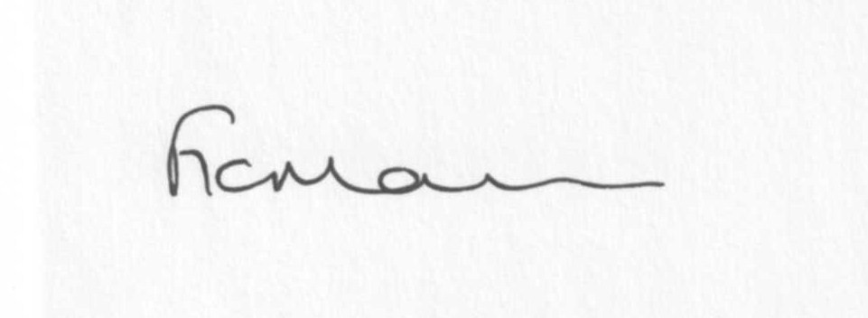
Mrs F Morris
Clerk to the Parish Council

AGENDA

0) Public participation (maximum 15 minutes)
1) Apologies for absence
2) Declaration of Interests
The Localism Act 2011, Relevant Authorities (Disclosable Pecuniary Interests) Regulations 2012.
Members are reminded that they are required to leave the room during the discussion and voting on matters in which they have a disclosable pecuniary interest, whether or not the interest is entered in the register of member’s interests maintained by the Monitoring Officer.
3) To confirm minutes of the meeting held on 24th March 2014 (copy attached)
4) Matters Arising from the minutes
(a) Progress report (distributed at meeting)
(b) Reply from SC re: parish problems and Chorley update
(c) Any other matters arising
5) Chancel Repair Liability update
6) Planning applications:
a) Reference: 14/01700/TCA (validated: 14/04/2014)
Address: Rosebank, 40 High Street, Stottesdon, Kidderminster, Shropshire, DY14 8TZ
Proposal: Notification of proposed works to include the felling of one Plum Tree and two Beech Trees and one Copper Beech Tree within the Stottesdon Conservation Area
Applicant: Mrs J Harris

b) Any others received after issue of agenda

c) Planning permissions/refusals:
7) SALC report
8) Unitary Councillor’s report
9) Church clock quote/update
10) Financial matters:
a) Outstanding payments: Clerks fees/HMRC PAYE/expenses, SALC training account, Parish Online renewal, Internet security renewal.
Any others received after issue of the agenda
b) Income since last meeting - confirmed at meeting
c) Bank statement
d) Year end Accounts/Budget/Audit
11) Parish matters/problems
a) Parish problems
b) Parish Watch
c) Community Right to Bid update
d) Footpath mowing – Glebe Drive/Church
12) Co-option – new Councillor?
13) Standing Orders/Financial Regulations update
14) Correspondence:
Emails forwarded include:
SALC Bulletins
RSN newsletters
Shropshire & Staffordshire Local Flood Risk Management survey
Came and Company newsletter
Tom Brettell – Change to Community Action team
Election poster
Shropshire Rural Hub newsletter
Public meeting about buses - 26th April, Baptist Church, Bridgnorth
Post 16 Student Transport consultation letter
SALC – Future Fit Engagement Event invitation
SALC – training event on New Financial Regulations Monday 16th June
Shropshire Health & Poverty report 2012/13
SALC – Meeting with Planning Minster information
Acknowledgements received for cheques from:
Stottesdon PCC
Sidbury PCC
Chorley Chapel
Willowdene Resources
Hope House
Severn Hospice
Marie Curie
Cleobury Mortimer Youth Partnership
Chorley Village Hall
SC – alterations to electoral roll
Mr Page – road/sign complaint
Any others received after issue of the agenda
15) Date of next meeting: May 19th Annual Parish Council meeting.
16) Update: Car parking/playing field ** - if anything to report.
**Due to the confidential nature of the business to be discussed under item 16 the public and press shall be excluded under s1 (2) Public Bodies (Admission to Meetings) Act 1960 as amended

