
Stottesdon and Sidbury Parish Council
Clerk: Mrs Freda Morris
18 Glebe Drive
Stottesdon
Kidderminster
Worcs
DY14 8UF

Telephone: 01746 718453
E-mail: stottesdonpc@btinternet.com

Date: 19th January 2014
To: All Parish Council members
The Public and Press

A Parish Council meeting will be held on MONDAY 27th JANUARY 2014 at 7.30pm in CHORLEY VILLAGE HALL for the transaction of business as set out in the agenda below which you are summoned to attend.

Yours sincerely

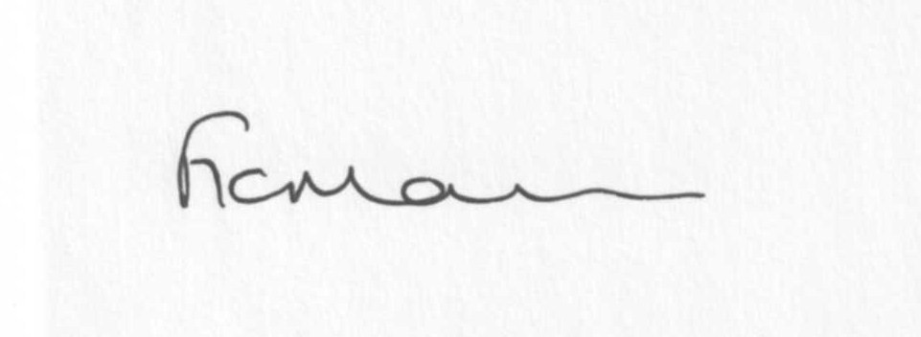
Mrs F Morris
Clerk to the Parish Council

AGENDA

0) Public participation (maximum 15 minutes)
1) Apologies for absence
2) Declaration of Interests
The Localism Act 2011, Relevant Authorities (Disclosable Pecuniary Interests) Regulations 2012.
Members are reminded that they are required to leave the room during the discussion and voting on matters in which they have a disclosable pecuniary interest, whether or not the interest is entered in the register of member’s interests maintained by the Monitoring Officer.
3) To confirm minutes of the meeting held on 16th December 2013 (copy attached)
4) Matters Arising from the minutes
(a) Progress report (distributed at meeting)
(b) Reply from SC re: parish problems
(c) Any other matters arising
5) School Bus
6) Chancel Repair Liability
7) Planning applications:
None received.

b) Any other plans received after issue of the agenda

c) Planning permissions/refusals:
Reference: 13/02439/FUL (validated: 03/07/2013)
Address: Timber Yard, Midwinters, Chorley, Bridgnorth, Shropshire, WV16 6PW
Proposal: Erection of steel portal agricultural building
Decision: Grant Permission

Reference: 13/04544/LBC (validated: 19/11/2013)
Address: Lower House Farm, Sidbury, Bridgnorth, WV16 6PY
Proposal: Renovation of dwelling including the creation of 4 no. new windows and the moving of one window affecting a Grade II Listed Building
Decision: Grant Permission

Reference: 13/03999/FUL (validated: 04/10/2013)
Address: Desert Woods, Billingsley, Highley, Bridgnorth, Shropshire
Proposal: Construction of new road - 20 year woodland management plan in place, approved in Nov 2012.
Decision: Grant Permission

Reference: 13/04446/FUL (validated: 07/11/2013)
Address: Bardley Court Cottage, Stottesdon, Kidderminster, Shropshire, DY14 8NE
Proposal: Erection of a two storey rear extension and alterations
Decision: Grant Permission

Any others received after issue of the agenda

8) SALC report
9) Unitary Councillor’s report
10) Financial matters:
a) Outstanding payments: Clerks fees/HMRC PAYE/expenses, Bus Shelter repair account. Willowdene account.
Any others received after issue of the agenda
b) Income since last meeting - confirmed at meeting
c) Bank statement
d) Precept
e) Ipad information
f) Funding requests: Sidbury Church, Marie Curie Cancer Care
11) Parish matters/problems
a) Parish problems
b) Parish Watch
c) Community Right to Bid
12) Annual Place Plan review 2013-14 – information attached
13) Chorley:
SatNav error sign – Bakehouse Lane, Chorley
Speed counter results
14) School Governor representative
15) Parish Council meeting dates
16) Risk Assessment
17) Asset Register
18) Correspondence:
Emails forwarded:
SALC Bulletins
Rural Services Network newsletters
SALC – Training event – 3rd and 12th February
SALC – Garden Parties 2014
LJC meeting – 23rd January (planning meeting) Cleobury Country
SALC - Condover PC request for PC support re: planning
SC – Outdoor Recreation Service User Survey
SC – Traffic Sensitive and Strategically Significant Street
Came and Co – Winter Advice
Patrick Cosgrove – Parish and Town Councils in support of better broadband
Cleobury Country training courses
Free Property flood protection assessment
Any others received after issue of the agenda
19) Date of next meeting – 24th February 2014
20) Update: Car parking/playing field **
**Due to the confidential nature of the business to be discussed under item 20 the public and press shall be excluded under s1 (2) Public Bodies (Admission to Meetings) Act 1960 as amended

