
Stottesdon and Sidbury Parish Council
Clerk: Mrs Freda Morris
18 Glebe Drive
Stottesdon
Kidderminster
Worcs
DY14 8UF

Telephone: 01746 718453
E-mail: stottesdonpc@btinternet.com

Date: 17th June 2012
To: All Parish Council members
The Public and Press

The Parish Council meeting will be held on MONDAY 25th JUNE 2012 at 7.30pm in CHORLEY VILLAGE HALL for the transaction of business as set out in the agenda below which you are summoned to attend.

Yours sincerely

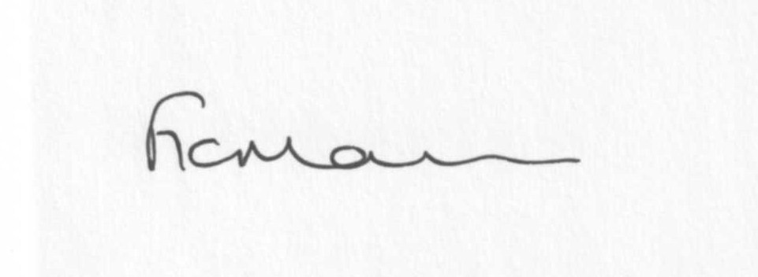
Mrs F Morris
Clerk to the Parish Council

AGENDA

0) Public participation
1) Apologies for absence
2) Declaration of Interests
“To receive declarations of Interest of personal and prejudicial interest on any item on the agenda in accordance with Section 50-52 of the Local Government Act & The Local Authorities (Model Code of Conduct) England Order 2001”.
3) To confirm minutes of the meeting held on 22n May, 2012(copy attached)
4) Matters Arising from the minutes
a) Progress report (distributed at meeting)
b) Bus shelter update
c) Any other matters arising
5) Planning applications:
a) Erection of agricultural building for feed/machinery storage and lambing shed – Willowdene
Farm, Chorley – App.no: 12/02355/FUL
b) Works to trees within Stottesdon Conservation Area – The Rectory, Stottesdon – App.no: 12/02506/TCA
c) any others received after issue of the agenda
d) Planning permissions/refusals
6) Shropshire Councillor’s report
7) SALC Report
8) Financial matters:
a) Accounts to be paid: Clerk’s fees/expenses. Any others received after issue of agenda
b) Audit Return completion
c) Internal Auditor’s report
d) Bank Statement
e) Income received since last meeting – VAT return refund
f) New printer
9) Correspondence (including emails forwarded to Councillors):
SC – FP6 – Public Path Diversion Order 2010 – Bakehouse Lane, Chorley
Emails:
22/5 – ALC Information Bulletin
22/5 – ALC – Draft Code of Conduct for Parishes
25/5 – Came and Co receipt for insurance
25/5 – Weekly planning list
25/5 – ALC Information Bulletin
28/5 – Rural Services Network (RSN) newsletter
30/5 – ALC Code of Conduct
1/6 – Weekly planning list
5/6 – Working with Shropshire Council
6/6 – RSN newsletter
8/6 – Weekly planning list
8/6 – Celebrate Britain’s Special Summer – community Games
11/6 – RSN newsletter
13/6 – RSN – 2012 Rural Insight survey
15/6 – Weekly planning list
15/6 – Cleobury & Rural LJC – British Gas Initiative
15/6 – Natural Environment Tree Scheme and Jubilee Planting programme
15/6 – ALC information Bulletin
18/6 – RSN newsletter
18/6 – ALC Letter for parishes – Code of Conduct
19/6 – TCPS Conference: creating garden cities and suburbs – planning for growth
Any others received after issue of the agenda
10) Parish matters/problems
a) Parish problems
b) Parish Watch
c) Parish Plan update
11) Jubilee coins update
12) Date of next meeting – 23rd July 2012

Please note deadline for newsletter is 1st July 2012

