
Stottesdon and Sidbury Parish Council
Clerk: Mrs Freda Morris
18 Glebe Drive
Stottesdon
Kidderminster
Worcs
DY14 8UF

Telephone: 01746 718453
E-mail: stottesdonpc@btinternet.com

Date: 17th February 2013
To: All Parish Council members
The Public and Press

A Parish Council meeting will be held on MONDAY 25th FEBRUARY 2013 at 7.30pm in CHORLEY VILLAGE HALL for the transaction of business as set out in the agenda below to which you are summoned to attend.

Yours sincerely
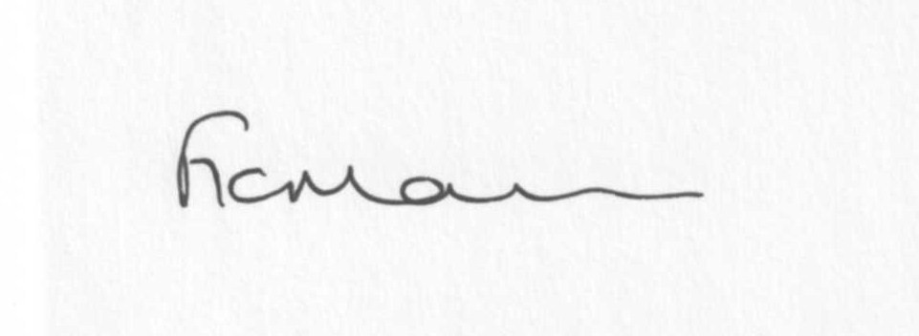
Mrs F Morris
Clerk to the Parish Council

AGENDA

0) Public participation
1) Apologies for absence
2) Declaration of Interests
The Localism Act 2011, Relevant Authorities (Disclosable Pecuniary Interests) Regulations 2012.
Members are reminded that they are required to leave the room during the discussion and voting on matters in which they have a disclosable pecuniary interest, whether or not the interest is entered in the register of member’s interests maintained by the Monitoring Officer.
3) Councillor’s dispensations:
4) To confirm minutes of the meeting held on 21st January 2013 (copy attached)
5) Matters Arising from the minutes
(a) Progress report (distributed at meeting)
6) Planning applications:
a) Reference: 13/00450/FUL (validated: 06/02/2013)
Address: Pool Meadow Orchard, Harcourt Lane, Stottesdon, Shropshire, DY14 8UQ
Proposal: Erection of an agricultural building to service proposed orchard development and house agricultural equipment
Applicant: Mr P Datlen (19 Glebe Drive, Stottesdon, Kidderminster, Worcestershire, DY14 8UF)

b) Reference: 13/00236/FUL(validated: 23/01/2013)
Address: Lower Chorley Farm, Chorley, Bridgnorth, Shropshire, WV16 6PP
Proposal: Renewal of extant planning permission 09/03211/FUL for the conversion of existing redundant cruck barn into one residential dwelling
Applicant: Mr N Jones

c) Reference: 12/02984/FUL
Address: Tanglewood, Midwinters, Chorley, Bridgnorth
Proposal: Erection of replacement dwelling following demolition of existing
Applicant: Mr S Boaler

Any others received after issue of the agenda

d) Permissions granted:
Reference: 12/05251/OHL (validated: 20/12/2012)
Address: Upper House Farm, Sidbury, Bridgnorth, Shropshire, WV16 6PY
Proposal: To divert approx 160m of existing HV lines to reinforce the network
Decision: No Objection OHL/Circular Notification

Reference: 12/05174/OHL (validated: 17/12/2012)
Address: Heath Farm, Burwarton, Bridgnorth, Shropshire, WV16 6RT
Proposal: Diversion of an existing 11kv overhead "single service" line
Decision: No Objection OHL/Circular Notification

Any others received after issue of the agenda

7) SALC report
8) Shropshire Councillor’s report
9) Financial matters
a) Outstanding payments: Clerks fees, Willowdene Account, Parish Online a/c. Crucial Crew Donation request. Any others received after issue of agenda
b) Income since last meeting (details distributed at meeting)
c) Bank statement
10) Correspondence – including emails forwarded to Cllrs by Clerk:
Election timetable
SC – Local Council Involvement in Minor Highway and Environmental Maintenance contract
SC – Dog Control Orders consultation
Acknowledgment email re: comments to Police and Crime Plan consultation
Weekly Planning lists
ALC Bulletins
Precept request acknowledgment
SC – road repairs B4363 – planned for March
Road Closures – Stottesdon School/The Square – 18th February for 4 days and Kinsleys/High Street – 22nd February for 2 days
Dog fouling complaint – Stottesdon
1/2/13 - ALC – SAMDev Plan – Draft Development Management Policies – Consultation until 31st March 2013
1/2/13 - ALC – Consultation on Shropshire Housing Renewal and Adaptations Policy
Electoral Roll updates
SC – road closure Hardwickforge – Station Road junction – 11th March for 2 weeks – bridge repairs.
Ambulance Service – AED training
Shropshire Fire & Rescue – newsletter information request
SC – Bus shelter base, Chorley – to be laid 18th/19th February
SC – Prescott Bridge – Proposed Structural Maintenance work
ALC – Change in Household Recycling Centre opening hours
LJC meeting – Lacon Childe School 7pm 21st February
Any others received after the issue of the agenda
11) Parish matters/problems
a) Parish problems
b) Parish Watch
12) To review the following documents: (emailed out separately)
Standing Orders
Financial Regulations
Asset Register
Risk Assessment
13) Date of next meeting - 25th March 2013
Due to the confidential nature of the business to be discussed under the Public Bodies (Admission to Meetings) Act 1960 and under s100 (A) of the Local Government Act 1972 the public and press shall be excluded for the remainder of the meeting for the following items of business on the grounds they may involve the likely disclosure of exempt information as defined by the Acts.

14) Parking – any update received
15) Playing field – any update received
Please note:
Deadline for newsletter articles 12 noon Friday 22nd February

