
Stottesdon and Sidbury Parish Council
Clerk: Mrs Freda Morris
18 Glebe Drive
Stottesdon
Kidderminster
Worcs
DY14 8UF

Telephone: 01746 718453
E-mail: stottesdonpc@btinternet.com

Date: 16th September 2012
To: All Parish Council members
The Public and Press

A Parish Council meeting will be held on MONDAY 24th SEPTEMBER 2012 at 7.30pm in CHORLEY VILLAGE HALL for the transaction of business as set out in the agenda below which you are summoned to attend.

Yours sincerely

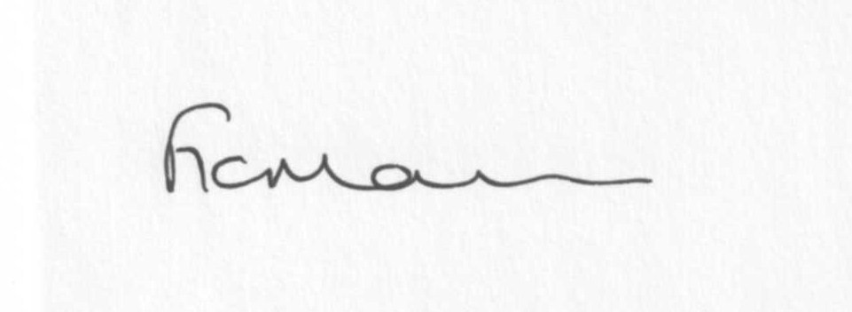

Mrs F Morris
Clerk to the Parish Council

AGENDA

0) Public participation
1) Apologies for absence
2) Declaration of Interests:
The Localism Act 2011, Relevant Authorities (Disclosable Pecuniary Interests) Regulations 2012.
Members are reminded that they are required to leave the room during the discussion and voting on matters in which they have a disclosable pecuniary interest, whether or not the interest is entered in the register of member’s interests maintained by the Monitoring Officer.
3) To confirm minutes of the meeting held on 20th August 2012 (copy attached)
4) Matters Arising from the minutes:
(a) Clerk’s report (distributed at meeting)
(b) Reply re: Walton Bank hedge
(c) Any other matters arising
5) Planning applications:
a) Any plans received after issue of agenda
b) Permissions/refusals: Chorley Manor Barns. Willowdene Farm.
6) SALC report
7) Shropshire Councillor’s report
8) Financial matters:
a) Outstanding payments: Clerk’s fees/expenses. Any others received after issue of agenda.
b) Income since last meeting (confirmed at meeting)
c) Bank statement
9) Bus shelter
10) Parish matters/problems
a) Parish problems
b) Parish Watch
c) Parish Plan update
11) Correspondence including emails forwarded to Councillors:
Letter from MP re: Abolition of the Standards Board/Openness on Councillor’s Interest
Ben Upton – Festival in Stottesdon?
Audit Commission – appointment of external auditors from 2012-13
Weekly Planning lists
Rural Service Network newsletters
29/8 Linda Jeavons - New Guidance from the Environment Agency
4/9 SALC - Bulletin
6/9 SC – Road Closure – Brooksmeeting, 24th September for 5 days – 9am-4pm – carriageway repairs
6/9 SC – Road closure – Withies Bank, Oreton – 8th October, 1 day 8am-4pm
6/9 Shropshire housing Alliance 4th AGM, The Guildhall, Shrewsbury, 25th October 3-5pm
7/9 Lower Severn Corridor Flood Forum meeting – 11th October 2pm, Council Chamber, Westgate, Bridgnorth
11/9 ALC Bulletin
13/9 SC – Road closure – Oreton Bank to Honeysuckle Lane – 22nd October, 1 day – carriageway repairs
Any others received after the issue of the agenda
12) Date of next meeting – 22nd October 2012

Please note:
Deadline for newsletter items 12 noon - 7th October.
Items received after this deadline will not be included.
Please keep articles to a maximum of 200 words.

