
Stottesdon and Sidbury Parish Council
Clerk: Mrs Freda Morris
18 Glebe Drive
Stottesdon
Kidderminster
Worcs
DY14 8UF

Telephone: 01746 718453
E-mail: stottesdonpc@btinternet.com

Date: 16TH November 2014

To: All Parish Council members
The Public and Press

A Parish Council meeting will be held on MONDAY 24TH NOVEMBER 2014 at 7.30pm in CHORLEY VILLAGE HALL for the transaction of business as set out in the agenda below which you are summoned to attend.

Yours sincerely

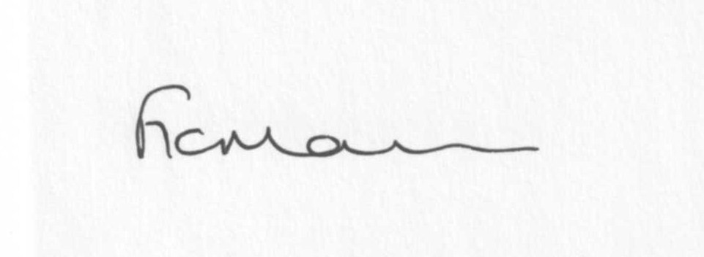

Mrs F Morris
Clerk to the Parish Council

AGENDA

0) Public participation (maximum 15 minutes)
1) Apologies for absence
2) Declaration of Interests
The Localism Act 2011, Relevant Authorities (Disclosable Pecuniary Interests) Regulations 2012.
Members are reminded that they are required to leave the room during the discussion and voting on matters in which they have a disclosable pecuniary interest, whether or not the interest is entered in the register of member’s interests maintained by the Monitoring Officer.
3) To confirm minutes of the meeting held on October 21st 2014 (copy attached)
4) Matters Arising from the minutes
(a) Progress report (distributed at meeting)
(b) Reply from SC re: parish problems
(c)Any other matters arising
5) a) Co-option of new Councillors
b) Signing of declaration of Acceptance of Office by newly elected Councillors
6) Planning applications:
a) TOWN AND COUNTRY PLANNING ACT 1990 - FOR INFORMATION ONLY
14/04847/AGR
Open span steel portal frame
Willowdene , Chorley, Bridgnorth, Shropshire, WV16 6PP
The above application has been submitted to this authority. Please note: this is not a formal consultation and is being sent to you FOR INFORMATION ONLY. This is not viewable online in Public Access.
b)) Any others received after issue of the agenda

b) Planning permissions/refusals:
If any received
7) SALC report
8) Unitary Councillor’s report
9) Financial matters:
a) Outstanding payments: Clerks fees/HMRC PAYE/expenses
Any others received after issue of the agenda
b) Income since last meeting - confirmed at meeting
c) Bank statement
d) Email from Claire Ratcliff (Cleeview Bridleways Group) re: financial support for clearing bridleway in parish
10) Parish matters/problems
a) Parish problems
b) Parish Watch
c) Complaint re: roads through Stottesdon and Rays Farm road (incomplete patch) – now completed
d) Complaint re: VAS, Station Road, Stottesdon – now repaired
11) Place Plan review – you can view the current plan on SC website
12) Standing Orders update
13) Road Safety policy – suggest additional areas to be included?
14) Correspondence:
Emails forwarded include:
SALC Bulletins
RSN newsletters
Rural Hub newsletter
SC - Single Affordable Plot Application Approval George and Charles Evans, Stottesdon
Community Health News - October 2014
Data Protection registration - receipt of payment ICO:00041385363.
Shropshire Community Space Conference – 11th November
SC – Severe weather/potholing scheme – ongoing programme of planned road closures
Reducing Flood Risk
Street lights at The Kinsleys, Stottesdon – timing requested to be altered
Planning For Climate Change Conference Series 4th December 2014 LONDON and 12th March 2015 DUBLIN
Severn Centre Highley Newsletter
Street signs – SC arranging to install these a.s.a.p.
Parish Council Casual Vacancy – Mr D Rix
Invitation to CAS AGM 26 November 2014 at Oswestry
AUTUMN CLEAN UP @ Chorley Village Hall SAT 22nd NOV 2014 from 10am – helpers welcome
Any others received after issue of the agenda
15) Date of next meeting: December 15th 2014.
16) Update: Car parking/playing field ** - if anything to report.
**Due to the confidential nature of the business to be discussed under item 16 the public and press shall be excluded under s1 (2) Public Bodies (Admission to Meetings) Act 1960 as amended

