
Stottesdon and Sidbury Parish Council
Clerk: Mrs Freda Morris
18 Glebe Drive
Stottesdon
Kidderminster
Worcs
DY14 8UF

Telephone: 01746 718453
E-mail: stottesdonpc@btinternet.com

Date: 16th March 2014
To: All Parish Council members
The Public and Press

A Parish Council meeting will be held on MONDAY 24th MARCH 2014 at 7.30pm in CHORLEY VILLAGE HALL for the transaction of business as set out in the agenda below which you are summoned to attend.

Yours sincerely

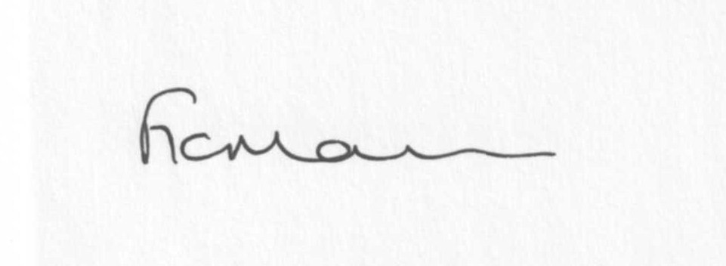
Mrs F Morris
Clerk to the Parish Council

AGENDA

0) Public participation (maximum 15 minutes)
1) Apologies for absence
2) Declaration of Interests
The Localism Act 2011, Relevant Authorities (Disclosable Pecuniary Interests) Regulations 2012.
Members are reminded that they are required to leave the room during the discussion and voting on matters in which they have a disclosable pecuniary interest, whether or not the interest is entered in the register of member’s interests maintained by the Monitoring Officer.
3) To confirm minutes of the meeting held on 24th February 2014 (copy attached)
4) Matters Arising from the minutes
(a) Progress report (distributed at meeting)
(b) Reply from SC re: parish problems
(c) Any other matters arising
5) Chancel Repair Liability update
6) Planning applications:
a) Reference: 14/00758/FUL (validated: 20/02/2014)
Address: The Highlands Farm, Sidbury, Bridgnorth, WV16 6PX
Proposal: Roofing of existing silage clamp and installation of two adjacent rainwater harvesting tanks on stone pad
Applicant: Mr Roger Williams (The Highlands Farm, Sidbury, Bridgnorth, Shropshire, WV16 6PX)
b) Any others received after issue of agenda
c) Planning permissions/refusals:
Reference: 14/00600/HRM (validated: 10/02/2014)
Address: Field to East of Lower Northwood Farm, Northwood Lane, Northwood, Stottesdon, Bridgnorth, Shropshire, WV16 6PT
Proposal: Remove 49m of hedgerow to enable efficient use of field
Decision: Grant Permission
7) SALC report
8) Unitary Councillor’s report
9) Church clock quote
10) Financial matters:
a) Outstanding payments: Clerks fees/HMRC PAYE/expenses.
Donation requests: Marie Curie
Sidbury Church.
Cleobury Mortimer Youth Partnership
Pentabus
Chorley Youth Quake
Any others received after issue of the agenda
b) Income since last meeting - confirmed at meeting
c) Bank statement
d) Ipad invoice confirmation purchase
11) Parish matters/problems
a) Parish problems
b) Parish Watch
c) Community Right to Bid update
d) Email from Stottesdon School re: parking outside school gate/speeding vehicles
e) Internal Auditor confirmation
12) Co-option – new Councillor?
13) Chorley/Stottesdon walkabout – signage approval
14) School Governor representative confirmation
15) Risk Assessment signing
16) Asset Register signing
17) Standing Orders/Financial Regulations update
18) Correspondence:
Emails forwarded:
SALC Bulletins
Rural Services Network newsletters
Tom Brettell – Connecting Shropshire presentation
Rural Hub Partnership Newsletter/support for farmers affected by flooding
Samaritans AGM invitation – 7th April 7.30pm, Wellington
Zurich insurance quotation request
Severn Centre customer survey
PWLB – repayment notification
Update from MP
CPRE – ‘Our Shropshire countryside is under threat’ – public meeting 3rd April, Shrewsbury
SC – Hackney Carriages & Private Hire Vehicles Provisions in Part II of the Local Government (Miscellaneous Provisions) Act 19676 - information request.
Any others received after issue of the agenda
19) Date of next meeting: 14th April 2014 – Annual Parish Meeting and 28th April 2014 – Parish Council meeting
20) Update: Car parking/playing field **
**Due to the confidential nature of the business to be discussed under item 20 the public and press shall be excluded under s1 (2) Public Bodies (Admission to Meetings) Act 1960 as amended

