
Stottesdon and Sidbury Parish Council
Clerk: Mrs Freda Morris
18 Glebe Drive
Stottesdon
Kidderminster
Worcs
DY14 8UF

Telephone: 01746 718453
E-mail: stottesdonpc@btinternet.com

Date: 17th February 2014
To: All Parish Council members
The Public and Press

A Parish Council meeting will be held on MONDAY 24th February 2014 at 7.30pm in CHORLEY VILLAGE HALL for the transaction of business as set out in the agenda below which you are summoned to attend.

Yours sincerely

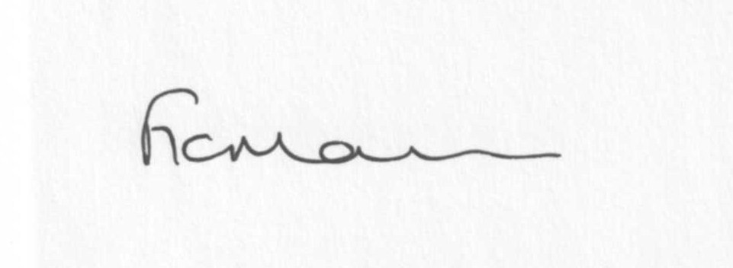
Mrs F Morris
Clerk to the Parish Council

AGENDA

0) Public participation (maximum 15 minutes)
1) Apologies for absence
2) Declaration of Interests
The Localism Act 2011, Relevant Authorities (Disclosable Pecuniary Interests) Regulations 2012.
Members are reminded that they are required to leave the room during the discussion and voting on matters in which they have a disclosable pecuniary interest, whether or not the interest is entered in the register of member’s interests maintained by the Monitoring Officer.
3) To confirm minutes of the meeting held on 27th January 2013 (copy attached)
4) Matters Arising from the minutes
(a) Progress report (distributed at meeting)
(b) Reply from SC re: parish problems
(c) Any other matters arising
5) School Bus update
6) Chancel Repair Liability update
7) Planning applications:
a) Reference: 14/00600/HRM (validated: 10/02/2014)
Address: Field To East Of Lower Northwood Farm, Northwood Lane, Northwood, Stottesdon, Bridgnorth, Shropshire, WV16 6PT
Proposal: Remove 49m of hedgerow to enable efficient use of field
Applicant: Mr M Fletcher (Greenacres, Bagginswood, Cleobury Mortimer, Worcs., DY14 8ND)

b) Any other plans received after issue of the agenda

c) Planning permissions/refusals:
Reference: 13/04879/FUL (validated: 04/12/2013)
Address: Coppice Barn, Chorley, Bridgnorth, Shropshire, WV16 6PP
Proposal: Erection of Oak Framed Garage including driveway and access.
Decision: Grant Permission

Reference: 13/04880/LBC (validated: 04/12/2013)
Address: Coppice Barn, Chorley, Bridgnorth, Shropshire, WV16 6PP
Proposal: Erection of garage including driveway and access
Decision: Grant Permission

Any others received after issue of the agenda

8) SALC report
9) Unitary Councillor’s report
10) Financial matters:
a) Outstanding payments: Clerks fees/HMRC PAYE/expenses, Willowdene account.
Any others received after issue of the agenda
b) Income since last meeting - confirmed at meeting
c) Bank statement
d) Precept confirmation
e) Ipad information
11) Parish matters/problems
a) Parish problems
b) Parish Watch
c) Community Right to Bid update
12) Co-option – new Councillor?
13) Chorley – confirmation date 25th February 9am Chorley Village Hall to look at providing signage etc
14) School Governor representative
15) Risk Assessment
16) Asset Register
17) Correspondence:
Emails forwarded:
SALC Bulletins
Rural Services Network newsletters
LJC meeting – 25th February Lacon Childe School
Lengthsman Scheme – invitation to join scheme again
Came and Co – Flooding advice
Cleobury Country training events
Any others received after issue of the agenda
18) Date of next meeting – 24th March 2014
19) Update: Car parking/playing field **
**Due to the confidential nature of the business to be discussed under item 19 the public and press shall be excluded under s1 (2) Public Bodies (Admission to Meetings) Act 1960 as amended

