
Stottesdon and Sidbury Parish Council
Clerk: Mrs Freda Morris
18 Glebe Drive
Stottesdon
Kidderminster
Worcs
DY14 8UF

Telephone: 01746 718453
E-mail: stottesdonpc@btinternet.com

Date: 15th March 2015
To: All Parish Council members
The Public and Press

A Parish Council meeting will be held on MONDAY 23rd MARCH 2015 at 7.30pm in CHORLEY VILLAGE HALL for the transaction of business as set out in the agenda below which you are summoned to attend.

Yours sincerely
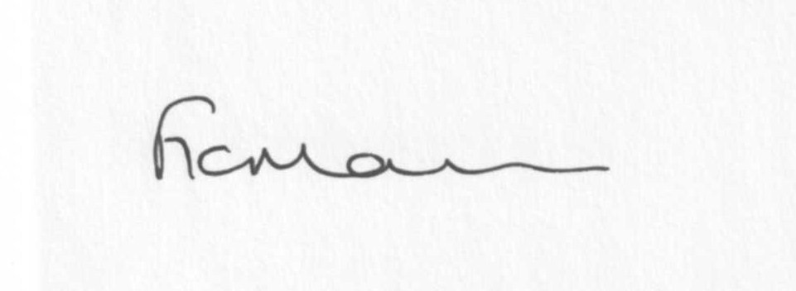
Mrs F Morris
Clerk to the Parish Council

AGENDA

0) Public participation (maximum 15 minutes)
1) Apologies for absence
2) Declaration of Interests
The Localism Act 2011, Relevant Authorities (Disclosable Pecuniary Interests) Regulations 2012.
Members are reminded that they are required to leave the room during the discussion and voting on matters in which they have a disclosable pecuniary interest, whether or not the interest is entered in the register of member’s interests maintained by the Monitoring Officer.
3) To confirm minutes of the meeting held on February 23rd 2015 (copy attached)
4) Matters Arising from the minutes
(a) Progress report (distributed at meeting)
(b) Reply from SC re: parish problems
(c) Telephone response from parishioner re: hedge
(d)Any other matters arising

5) Planning applications:
a) Reference: 15/00298/TCA (validated: 27/02/2015)
Address: Stottesdon C E Primary School, Stottesdon, Kidderminster, Shropshire, DY14 8UE
Proposal: Fell 1No Poplar Lombardy Tree lying within Stottesdon Conservation Area
Applicant: Mrs Katie Jones

b) Any others received after issue of agenda
c) Planning permissions/refusals- if any received after issue of agenda
6) SALC report
7) Unitary Councillor’s report
8) Financial matters:
a) Outstanding payments: Clerks expenses and fees/HMRC PAYE, Willowdene Resources (Lengthsman scheme account), Burial Grants, CleoburyYouth Partnership grant, Chorley Village Hall account. PWLB – Repayment notice
Any others received after issue of the agenda
b) Income since last meeting - confirmed at meeting
c) Bank statement
9) Policy Updates: Standing Orders, Financial Regs, Asset Register, Risk Assessment
10) Parish matters/problems
a) Parish problems
b) Parish Watch
11) Correspondence:
Emails forwarded include:
SALC Bulletins
RSN newsletters
SC – Electoral Roll updates
SALC – CTSG decision
SC – BW16 reply
SC – Reply re: trees at Midwinters
Samaritans AGM 13th April, Wellington
Stottesdon School re: potholes
SC – Outdoor Recreation newsletter
Local Council Award registration reply
Any others received after issue of agenda
12) Date of next meeting: 13th April – Annual Parish Meeting and 20th Parish Council meeting

REMINDER:
Articles for the next newsletter required by the 29th March 12 noon deadline. Please keep articles to a maximum of 200 words.

