
Stottesdon and Sidbury Parish Council
Clerk: Mrs Freda Morris
18 Glebe Drive
Stottesdon
Kidderminster
Worcs
DY14 8UF

Telephone: 01746 718453
E-mail: stottesdonpc@btinternet.com

Date: 14th September 2014
To: All Parish Council members
The Public and Press

A Parish Council meeting will be held on MONDAY 22nd SEPTEMBER 2014, at 7.30pm in CHORLEY VILLAGE HALL for the transaction of business as set out in the agenda below which you are summoned to attend.

Yours sincerely

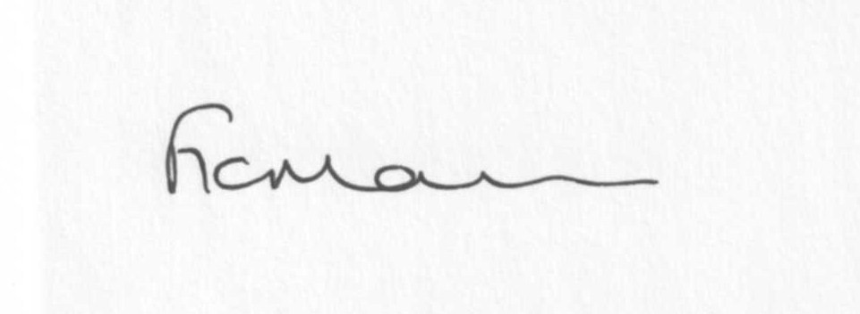
Mrs F Morris
Clerk to the Parish Council

AGENDA

0) Public participation (maximum 15 minutes)
1) Apologies for absence
2) Declaration of Interests
The Localism Act 2011, Relevant Authorities (Disclosable Pecuniary Interests) Regulations 2012.
Members are reminded that they are required to leave the room during the discussion and voting on matters in which they have a disclosable pecuniary interest, whether or not the interest is entered in the register of member’s interests maintained by the Monitoring Officer.
3) To confirm minutes of the meeting held on August 18th 2014 (copy attached)
4) Matters Arising from the minutes
(a) Progress report (distributed at meeting)
(b) Reply from SC re: parish problems
(c)Report re: meeting with Jez Morris and Alice Dilly
(d) Any other matters arising
5) Planning applications:
a) Reference: 14/03840/FUL (validated: 05/09/2014)
Address: The Hawthorns, Chorley, Bridgnorth, WV16 6PP
Proposal: Erection of two storey and single storey rear extensions
Applicant: Mr P Wood

b) Reference: 14/03842/FUL (validated: 09/09/2014)
Address: Stanley Farm, Chorley, Bridgnorth, WV16 6PS
Proposal: Erection of 6 log cabins for a mix of holiday lets and accommodation for rehabilitation centre clients
Applicant: Dr Matthew Home (Willowdene Farm, Chorley, Bridgnorth, Shropshire, wv16 6pp)

c) Reference: 14/04127/HRM (validated: 12/09/2014)
Address: Field To West Of Scots House, Chorley, Bridgnorth, Shropshire, WV16 6PR
Proposal: Removal of 75m of hedgerow to facilitate modern arable farming
Applicant: Mr Sam Jones (Lowe Farm, Farlow, Kidderminster, Worcestershire, DY14 0RT)
d) FOR INFORMATION ONLY
PLANNING REFERENCE: 14/04041/AGR
DEVELOPMENT PROPOSED: Steel portal frame general purpose building with fibre cement roof and box profile/concrete panel clad
LOCATION: Land To The East Of Stottesdon, Shropshire
OS REFERENCE: 367964 - 282711
APPLICANT: Mr Ian Morris

e) Any others received after issue of agenda

f) Planning permissions/refusals:
Any received after issue of agenda

7) SALC report
8) Unitary Councillor’s report
9) Financial matters:
a) Outstanding payments: Clerks fees/HMRC PAYE/expenses, Audit fee
Any others received after issue of the agenda
b) Income since last meeting - confirmed at meeting
c) Bank statement
d) Bank Signatories
e) Reply from External Audit
f) PWLB payment notification
10) Parish matters/problems
a) Parish problems
b) Parish Watch
c) Road name signs
11) Co-option – new Councillors
12) Standing Orders/Financial Regulations update
13) Correspondence:
Emails forwarded include:
SALC Bulletins
RSN newsletters
SALC – Submission of SC SAMDev Plan to the Secretary of State
SALC – Community Health Review 2014-09-15 Shropshire Housing Alliance – AGM 23rd October, 3-5pm at Shirehall
SALC – Shropshire Urgent Care
SC – Electoral Roll alterations
Came and Co newsletter
SALC – Place Plan Review
SALC - Future Fit Shortlisting
SALC - £20,000 available for Community projects
SALC – Shropshire Schools Sustainability
SALC – Stoptober campaign
Any others received after issue of the agenda
14) Date of next meeting: September 22nd 2014.
15) Update: Car parking/playing field ** - if anything to report.
**Due to the confidential nature of the business to be discussed under item 15 the public and press shall be excluded under s1 (2) Public Bodies (Admission to Meetings) Act 1960 as amended

