
Stottesdon and Sidbury Parish Council
Clerk: Mrs Freda Morris
18 Glebe Drive
Stottesdon
Kidderminster
Worcs
DY14 8UF

Telephone: 01746 718453
E-mail: stottesdonpc@btinternet.com

Date: 10th August 2014
To: All Parish Council members
The Public and Press

A Parish Council meeting will be held on MONDAY 18th AUGUST 2014, at 7.30pm in CHORLEY VILLAGE HALL for the transaction of business as set out in the agenda below which you are summoned to attend.

Yours sincerely

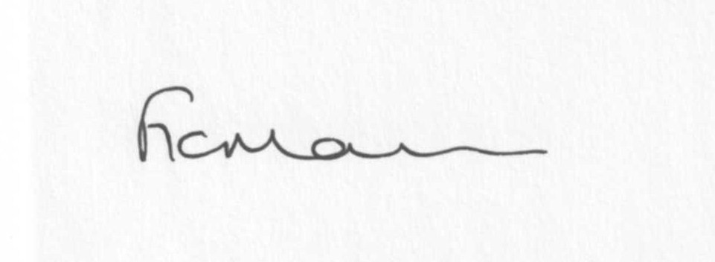
Mrs F Morris
Clerk to the Parish Council

AGENDA

0) Public participation (maximum 15 minutes)
1) Apologies for absence
2) Declaration of Interests
The Localism Act 2011, Relevant Authorities (Disclosable Pecuniary Interests) Regulations 2012.
Members are reminded that they are required to leave the room during the discussion and voting on matters in which they have a disclosable pecuniary interest, whether or not the interest is entered in the register of member’s interests maintained by the Monitoring Officer.
3) To confirm minutes of the meeting held on July 28th 2014 (copy attached)
4) Matters Arising from the minutes
(a) Progress report (distributed at meeting)
(b) Reply from SC re: parish problems
(c)Reply from Wade Muggleton/School re: trees at school field
(d) Any other matters arising
5) Planning applications:
a) Any received after issue of the agenda

c) Planning permissions/refusals:
a) Reference: 14/02898/FUL (validated: 30/06/2014)
Address: The Owl House, Hawkswood Barn, Billingsley, Bridgnorth, WV16 6PL
Proposal: Erection of a detached double garage and log store
Decision: Grant Permission

b) any others received after issue of the agenda
7) SALC report
8) Unitary Councillor’s report
9) Financial matters:
a) Outstanding payments: Clerks fees/HMRC PAYE/expenses, SC Election expenses account.
Any others received after issue of the agenda
b) Income since last meeting - confirmed at meeting
c) Bank statement
d) Bank Signatories
e) Reply from Mrs V Hall, Internal Auditor
f) Cheque Sidbury PCC
10) Parish matters/problems
a) Parish problems
b) Parish Watch
c) Report of meeting with SC re: road name signs
d) Meeting arranged with Jez Morris and Alice Dilly from Shropshire Council re: parking
issues – Thursday 4th September 3pm Glebe Drive
e) Pinch pint outside Moonbeam House
11) Co-option – new Councillor/discuss options available
12) Standing Orders/Financial Regulations update
13) Correspondence:
Emails forwarded include:
SC road closure: Road which is closed: Rays Bridge Jct with B4363 to Ferny Hall, Billingsley
Date and duration: 15 September 2014 for 2 days from 8.00am until 5.00pm
Purpose: Carriageway resurfacing
Applicant: Ringway on behalf of Shropshire Council
SALC Bulletins
RSN newsletters
Leader Survey – confirmation of receipt and thanks for completing
SC – Build your own affordable housing – confirmation of local connection
Shropshire Local Flood Risk Management Strategy update
SALC – Shropshire Women’s and Children’s Centre
SALC – Free trees for planting in Shropshire
SALC – NHS Future Fit event August and September
SALC – Legal Notice to Parish & Community Councils – Hackney Carriages and Private Hire Vehicles
Any others received after issue of the agenda
14) Planning site visits document
15) Date of next meeting: September 22nd 2014.
16) Training updates – Fundamentals for Councillors, Kinlet Village Hall, 2nd September
17) Update: Car parking/playing field ** - if anything to report.
**Due to the confidential nature of the business to be discussed under item 17 the public and press shall be excluded under s1 (2) Public Bodies (Admission to Meetings) Act 1960 as amended

Please note:
Deadline for newsletter items – 12 noon on 21st September 2014.
Please keep articles to a maximum of 200 words.

