
Stottesdon and Sidbury Parish Council
Clerk: Mrs Freda Morris
18 Glebe Drive
Stottesdon
Kidderminster
Worcs
DY14 8UF

Telephone: 01746 718453
E-mail: stottesdonpc@btinternet.com

Date: 7th December 2014
To: All Parish Council members
The Public and Press

A Parish Council meeting will be held on MONDAY 15th DECEMBER 2014 at 7.30pm in CHORLEY VILLAGE HALL for the transaction of business as set out in the agenda below which you are summoned to attend.

Yours sincerely

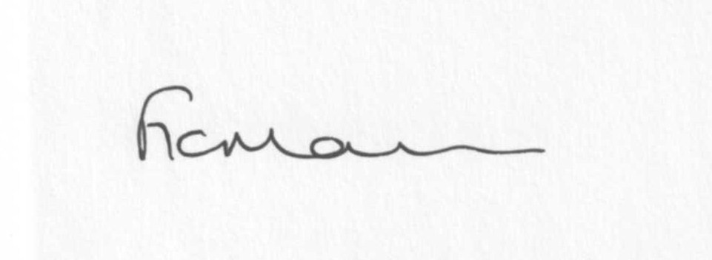

Mrs F Morris
Clerk to the Parish Council

AGENDA

0) Public participation (maximum 15 minutes)
1) Apologies for absence
2) Declaration of Interests
The Localism Act 2011, Relevant Authorities (Disclosable Pecuniary Interests) Regulations 2012.
Members are reminded that they are required to leave the room during the discussion and voting on matters in which they have a disclosable pecuniary interest, whether or not the interest is entered in the register of member’s interests maintained by the Monitoring Officer.
3) To confirm minutes of the meeting held on November 24th 2014 (copy attached)
4) Matters Arising from the minutes
(a) Progress report (distributed at meeting)
(b) Reply from SC re: parish problems
(c) Reply re: car rallies
(d)Any other matters arising
5) a) Co-option of new Councillor – 1 vacancy
b) Signing of declaration of Acceptance of Office by newly elected Councillor
6) Planning applications:
a) Reference: 14/05315/TCA (validated: 25/11/2014)
Address: Stottesdon C E Primary School, Stottesdon, Kidderminster, Shropshire, DY14 8UE
Proposal: To remove all major deadwood more than 80mm in diameter and stubbs from throughout the crown of 1No Poplar Lombardy (21) within Stottesdon Conservation Area
Applicant: Mrs Katie Jones

b) Reference: 14/05375/TCA (validated: 28/11/2014)
Address: Aranby, The Square, Stottesdon, Kidderminster, Shropshire, DY14 8UB
Proposal: To fell one Leylandii tree and reduce the height of one Maple tree by approx. 2m and remove some lower branches to maintain shape within Stottesdon Conservation Area
Applicant: Mrs Christine Haydon

c) Reference: 14/05022/FUL (validated: 28/11/2014)
Address: The Malthouse , Station Road, Stottesdon, Kidderminster, DY14 8TT
Proposal: Erection of a single storey rear and side extension following demolition of existing
Applicant: Mr John Kingston

d) Any others received after issue of the agenda

e) Planning permissions/refusals:
If any received
7) SALC report
8) Unitary Councillor’s report
9) Financial matters:
a) Outstanding payments: Clerks fees/HMRC PAYE/expenses, Lengthsman scheme a/c,
SLCC subsription
Any others received after issue of the agenda
b) Income since last meeting - confirmed at meeting
c) Bank statement
d) Email from Claire Ratcliff (Cleeview Bridleways Group) re: financial support for clearing bridleway in parish
e) To consider precept requirement for next meeting
10) Parish matters/problems
a) Parish problems
b) Parish Watch
11) Place Plan review – you can view the current plan on SC website/confirm comments from last meeting – form to be signed off by Unitary Cllr and Chairman
12) Correspondence:
Emails forwarded include:
SALC Bulletins
RSN newsletters
Rural Hub newsletter
SC – Electoral Roll distribution
SC – Highways severe weather/potholing schemes - ongoing programme of planned road closures.
SC - Outdoor Partnerships Winter Newsletter
Any others received after issue of the agenda
13) Date of next meeting: January 26th 2015
14) Update: Car parking/playing field ** - if anything to report.
**Due to the confidential nature of the business to be discussed under item 14 the public and press shall be excluded under s1 (2) Public Bodies (Admission to Meetings) Act 1960 as amended

